Charlie Qu

Period 0-2

Mason/Hansen

1/12/23

***AWS Labs 1-3***



Purpose:

Lab 1: IAM Basics: Learn the basics of AWS Identity and Access Management (IAM). Create and manage users in groups, explore permissions, and apply policies for service access.

Lab 2: VPC Setup and Web Server Deployment: Set up a custom Virtual Private Cloud (VPC) using AWS. Create a security group and deploy a web server on an Elastic Compute Cloud (EC2) instance within the VPC.

Lab 3: EC2 Essentials: Explore AWS Elastic Compute Cloud (EC2) features. Set up, monitor, and resize EC2 instances for scalability. Test termination protection, launch web servers, and adjust access permissions through security groups.

Background Information:

Lab 1: IAM Basics - AWS Identity and Access Management (IAM) simplifies access control to AWS resources. Users, groups, roles, and policies are IAM components that manage authentication and authorization. The root account provides full administrative access. Users have unique usernames and restricted default actions. Groups streamline permissions for multiple users, reducing administrative tasks. Roles offer temporary credentials, granting temporary access. Policies, stored as JSON documents, define permissions and access control. IAM features include account sharing, specified permissions, multi-factor authentication, identity federation, free usage, and a strong password policy.

Lab 2: VPC and Web Server - Amazon Virtual Private Cloud (VPC) is an isolated network for scalable AWS resource deployment. Components include subnets for visibility, route tables for traffic direction, virtual private gateway for secure connections, VPC peering for traffic routing, security groups for firewall rules, and VPC endpoints for internet-free connections. Set up a VPC with these components to enhance resource control, connectivity, and security.

Lab 3: EC2 Basics - Amazon Elastic Compute Cloud (EC2) provides scalable computing in the AWS Cloud. Features include virtual environment customization, user-selectable operating systems, software options on AWS Marketplace, and flexible volume scaling for dynamic scenarios. EC2 reduces costs and accelerates application development.

Lab Summary:

Lab 1: IAM Basics - Explore AWS Identity and Access Management (IAM) by adding pre-defined Users and Groups to your IAM console. Use IAM policies to grant specific permissions, regulating their access to AWS resources. Manage users with login credentials, facilitating their access to the resource environment.

Lab 2: VPC Setup and Web Server - Create a personalized Virtual Private Cloud (VPC) using Amazon VPC. Configure security groups and launch an EC2 instance as a web server within a designated VPC subnet. Use the VPC console to create resources like Internet Gateway, public and private subnets, route tables, and a NAT Gateway in a single Availability Zone.

Lab 3: EC2 Essentials - Gain fundamental knowledge of Amazon Elastic Compute Cloud (EC2). Launch a web server with termination protection, monitor the EC2 instance, adjust security groups for HTTP access, resize the instance for scalability, and explore EC2's capabilities and limitations. Enhance cloud computing efficiency for developers with this scalable compute capacity in the cloud.

Lab Commands:

N/A

Network Diagram:

Lab 1: Introduction to AWS IAM:

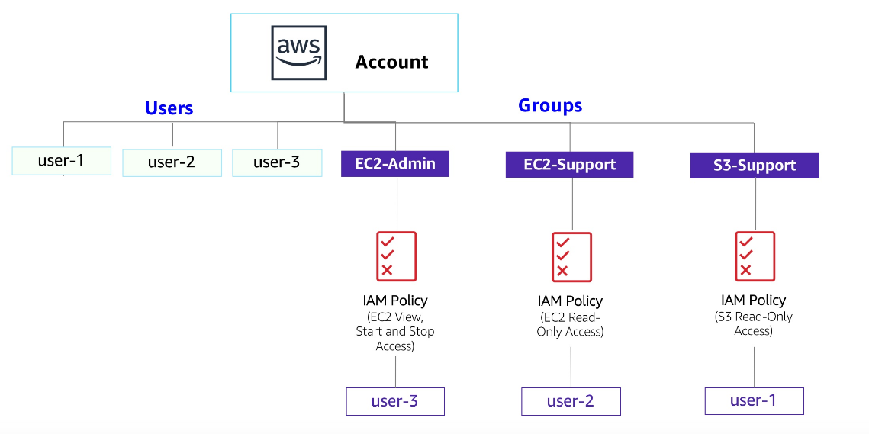

Lab 2: Build Your VPC and Launch a Web Server:

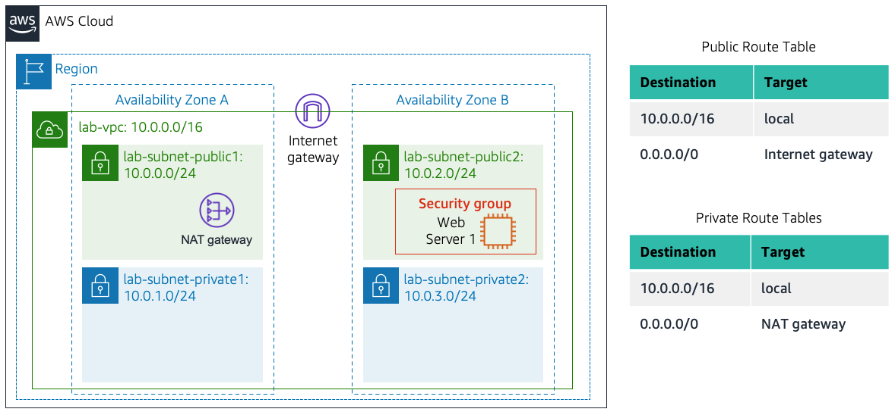

Lab 3: Introduction to Amazon EC2:

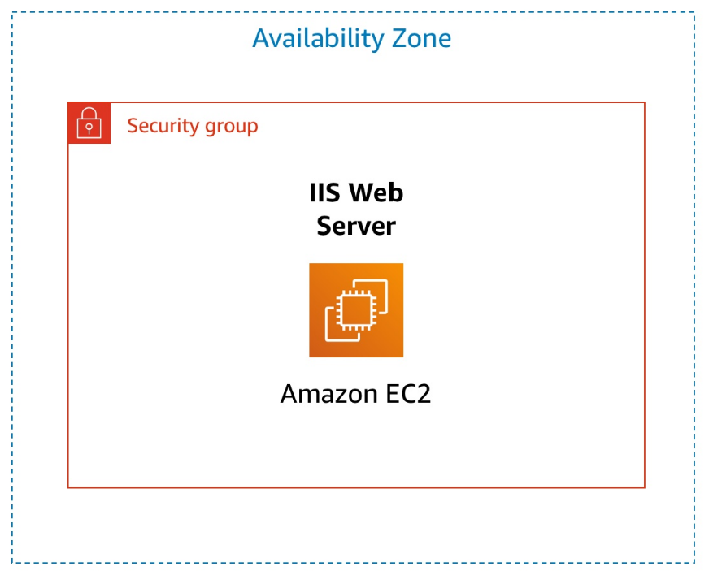

Configurations:

Lab 1: Introduction to AWS IAM

Step 1: In the Management Console of AWS, under the Services menu, choose IAM.

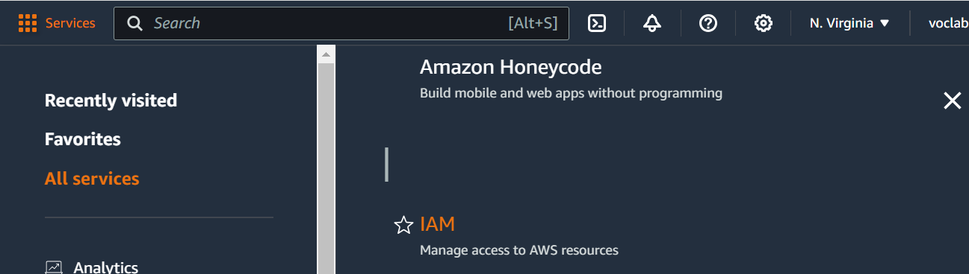

Step 2: In the left sidebar, select Users. (Three IAM Users have already been created: user-1, user-2, and user-3)

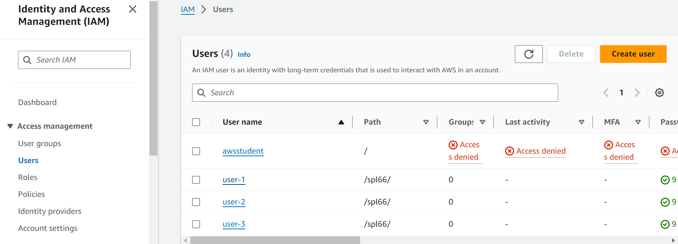

Step 3: Select user-1. (This brings you to user-1’s summary page. The Permissions tab is displayed. Notice that user-1 currently does not have any permissions)

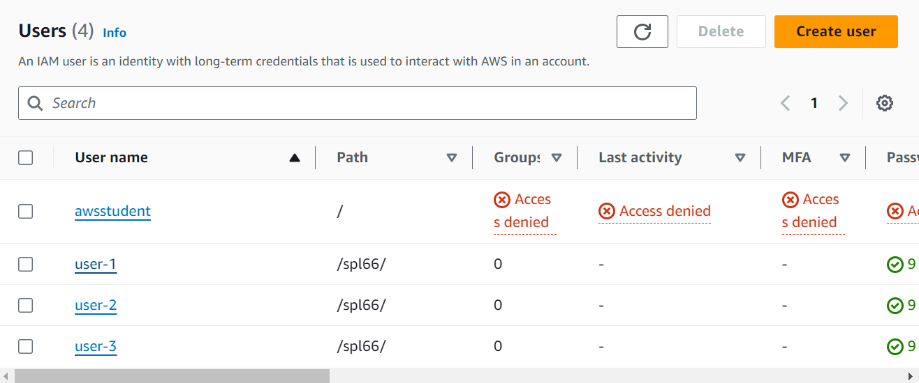

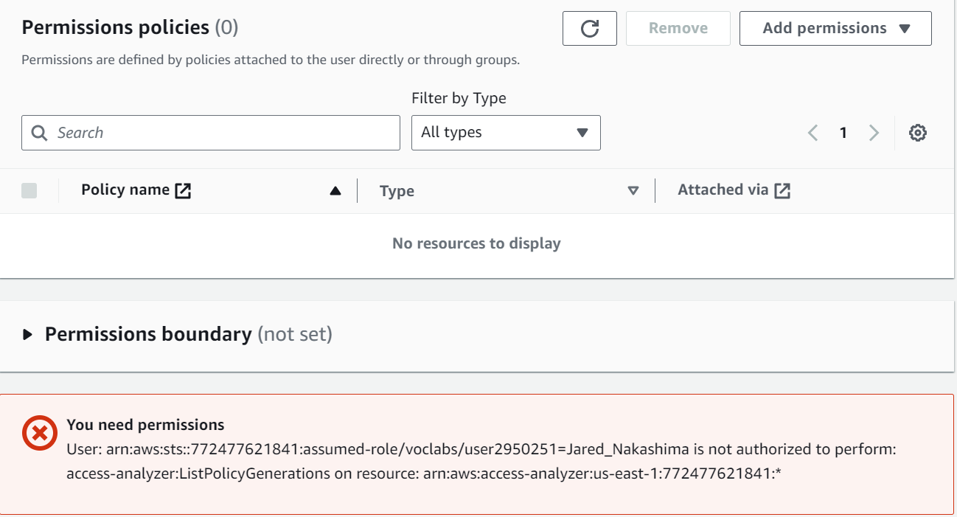

Step 4: Select the Groups tab and notice that user-1 is a not a member of a group. Then select the Security Credentials tab where user-1 has been assigned a Console Password.

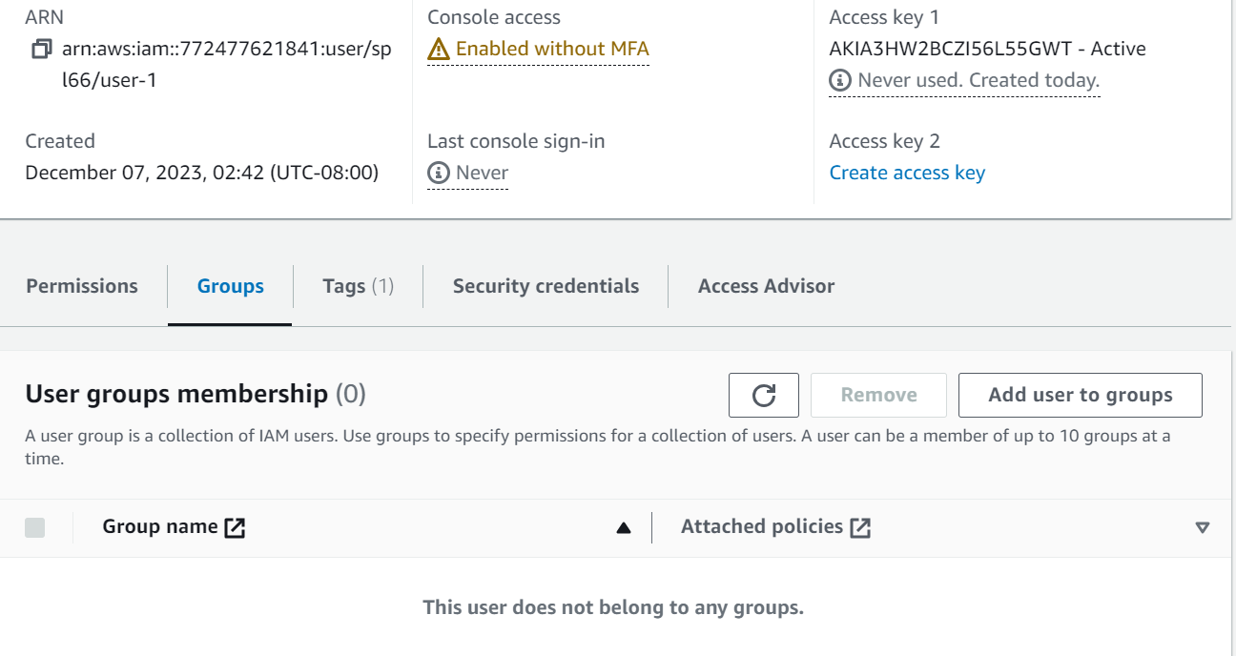

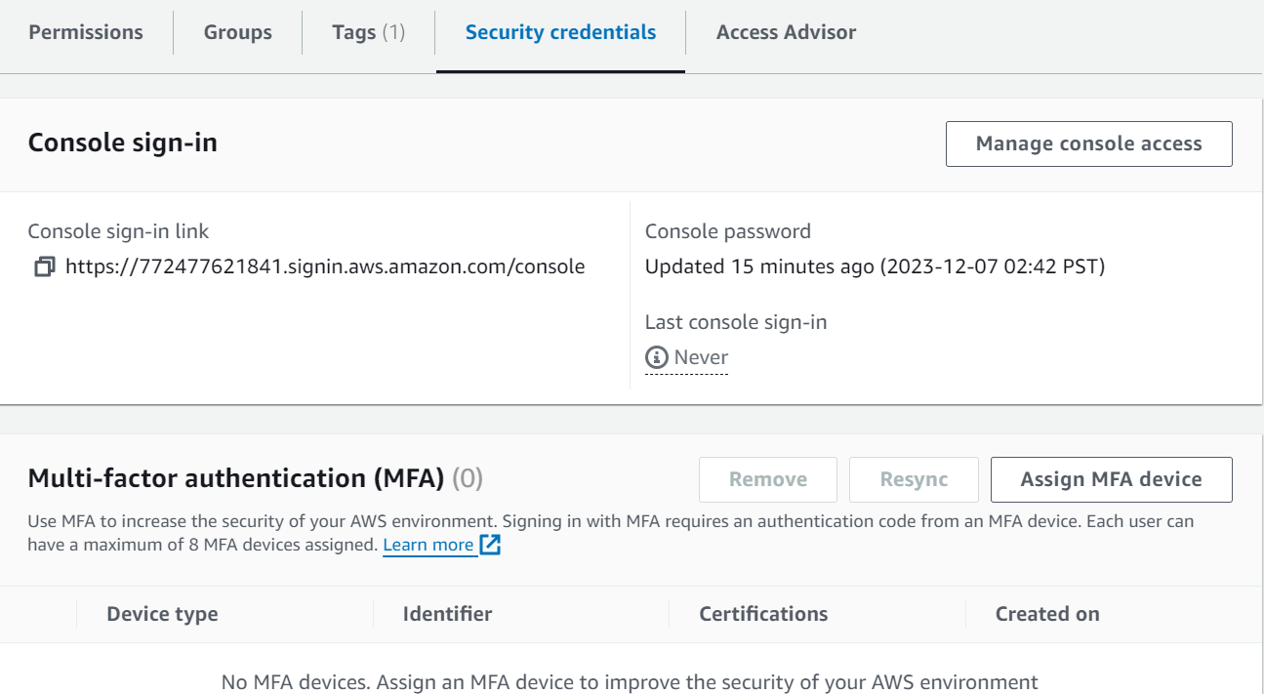

Step 5: In the left sidebar, select User Groups. (Three groups have already been created; EC2-Admin, EC2-Support, and S3-Support)

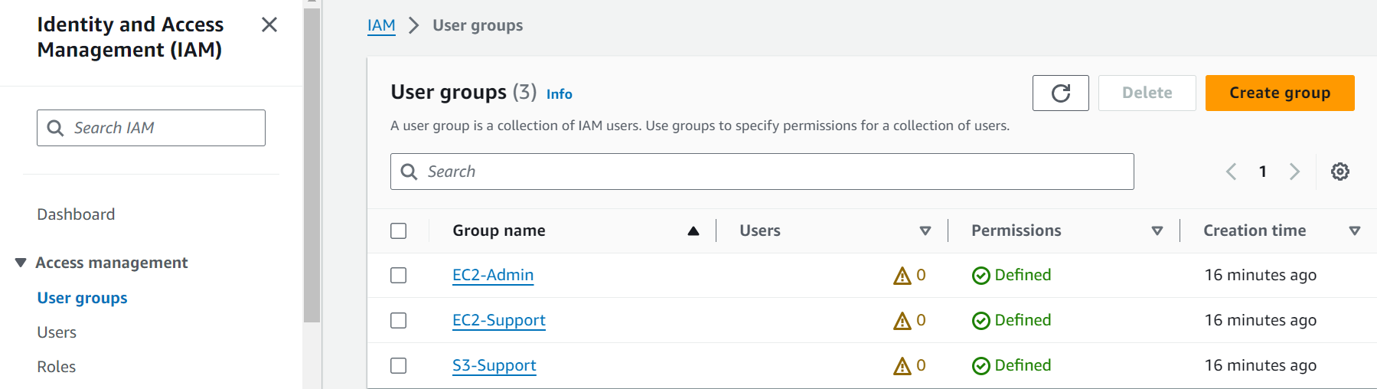

Step 6: Select the EC2-Support group and then choose the Permissions tab. This group contains a Managed Policy called AmazonEC2ReadOnlyAccess. Click on the (+) icon next to the policy name to expand the policy’s details. (The basic structure of statements in an IAM Policy is – Effect: Decides to Allow or Deny the permissions; Action: Specifies the API calls made against an AWS Service; Resource: Defines the scope of entities covered by the policy’s rule)

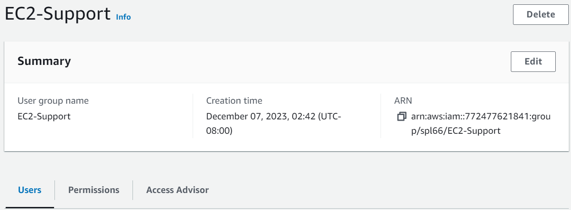

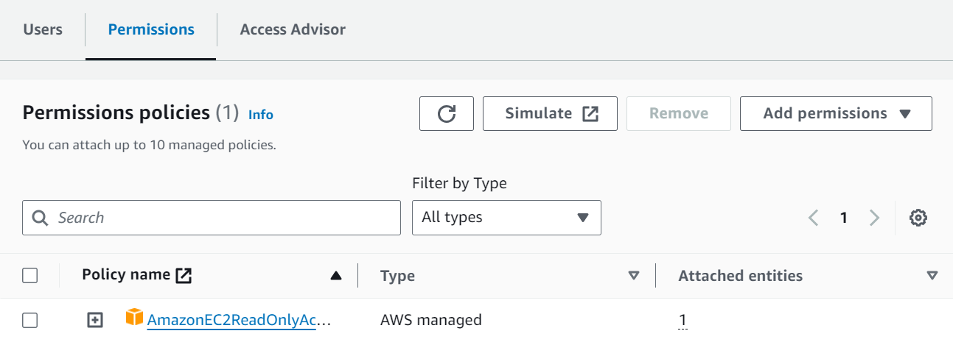

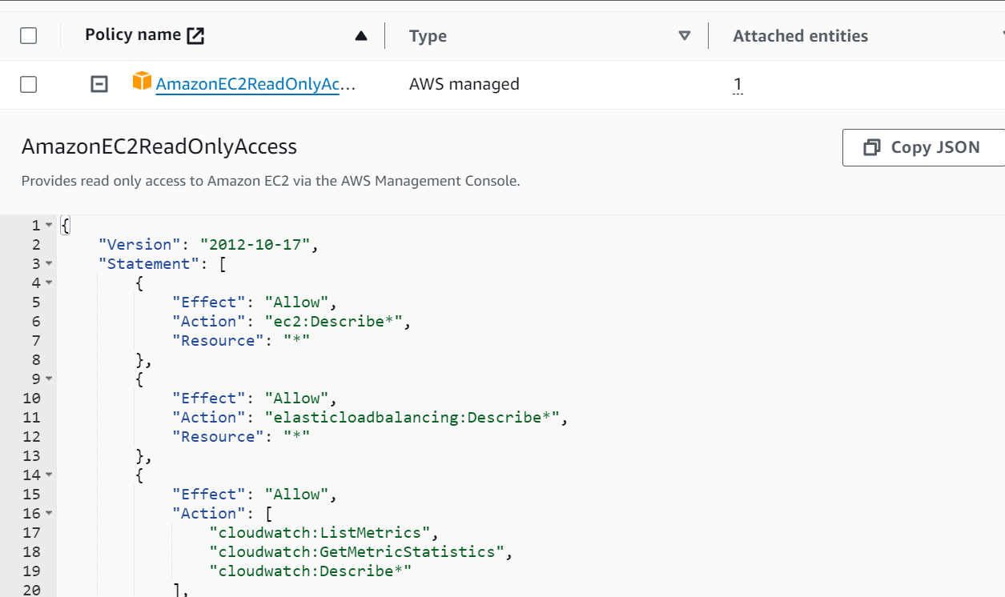

Step 7: Renavigate to User Groups in the left sidebar and select the S3-Support group. Choose the Permissions tab and view the AmazonS3ReadOnlyAccess policy attached using the (+) icon.

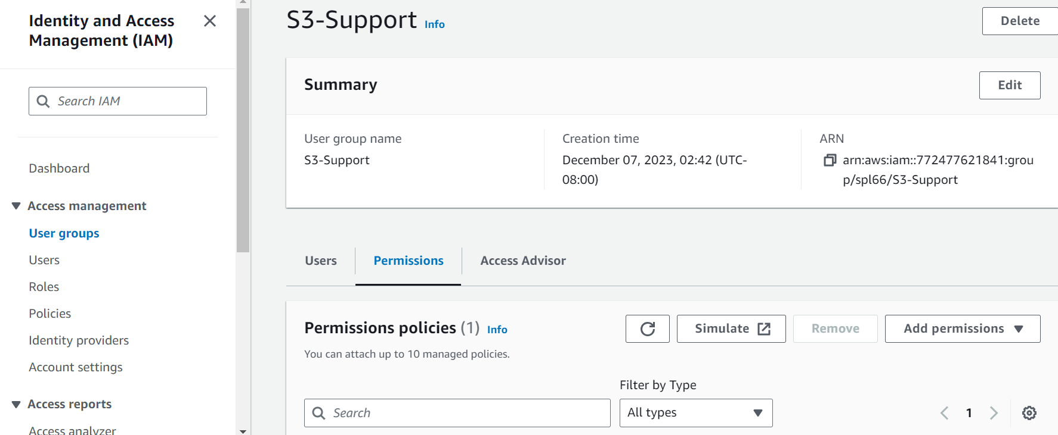

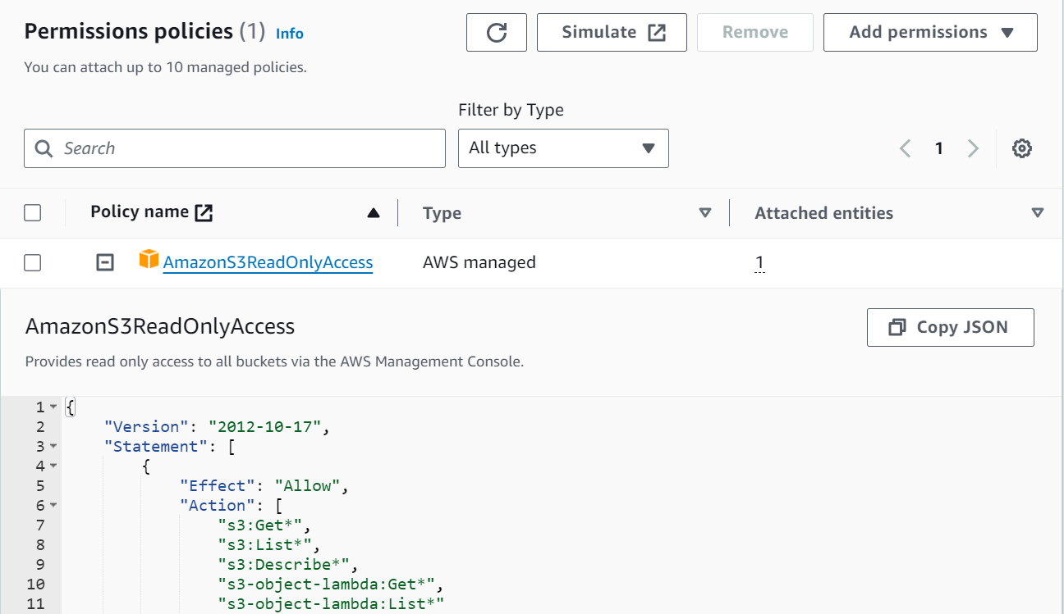

Step 8: Renavigate to User Groups once more in the left sidebar and select the EC2-Admin group. Choose the Permissions tab and view its Inline Policy details using the (+) icon. (Notice that this type of policy is only assigned to just one User or Group. This policy also provides access to view information on Amazon Ec2, with the ability to Start and Stop instances)

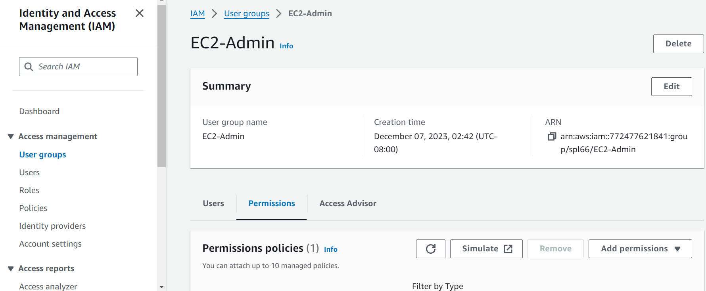

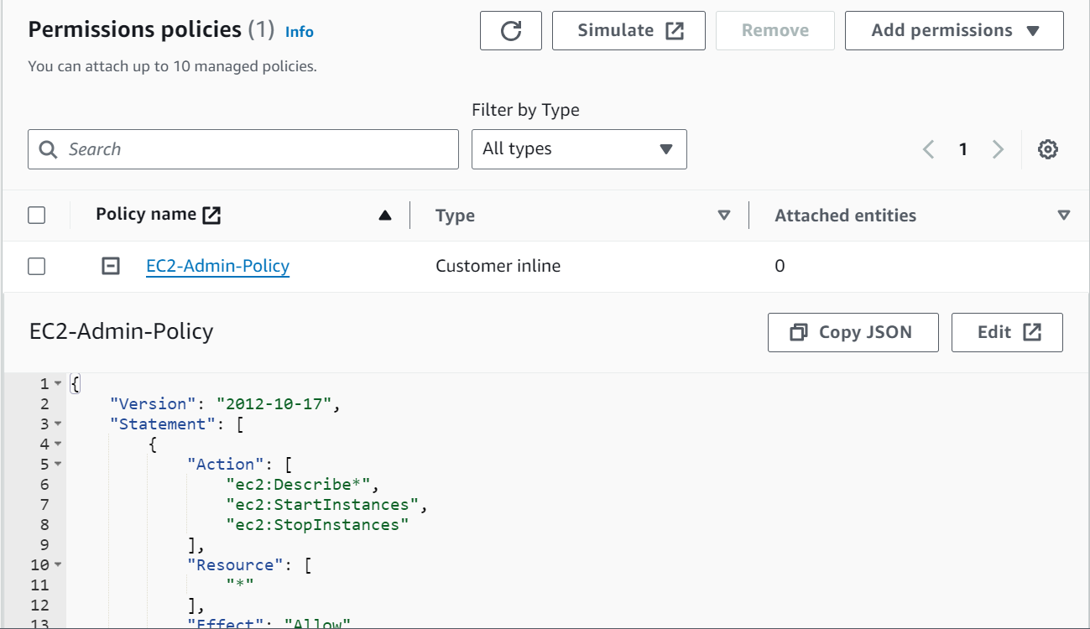

Step 9: In the left sidebar, select User Groups. Select the S3-Support group and under the Users tab, click on Add Users.

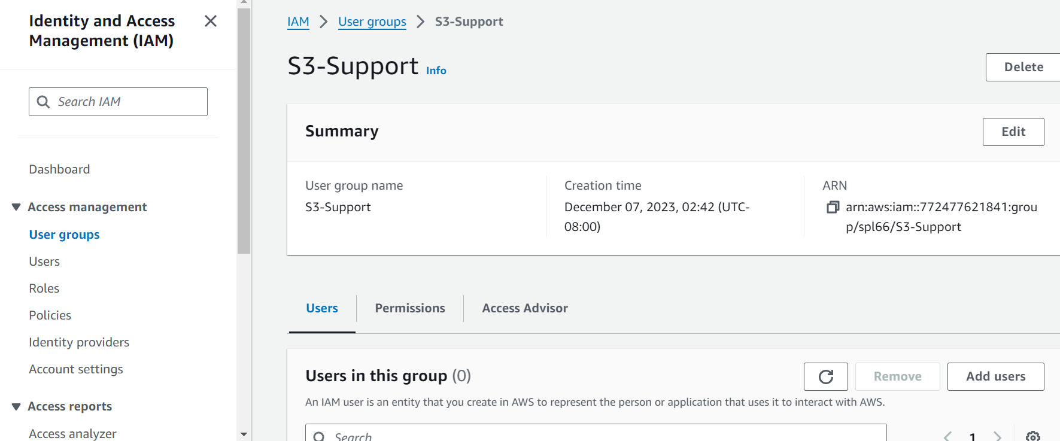

Step 10: In the Add Users to S3-Support window, choose user-1. Then scroll to the bottom of the screen and click on Add Users. (You will see in the Users tab that user-1 has been added to the group)

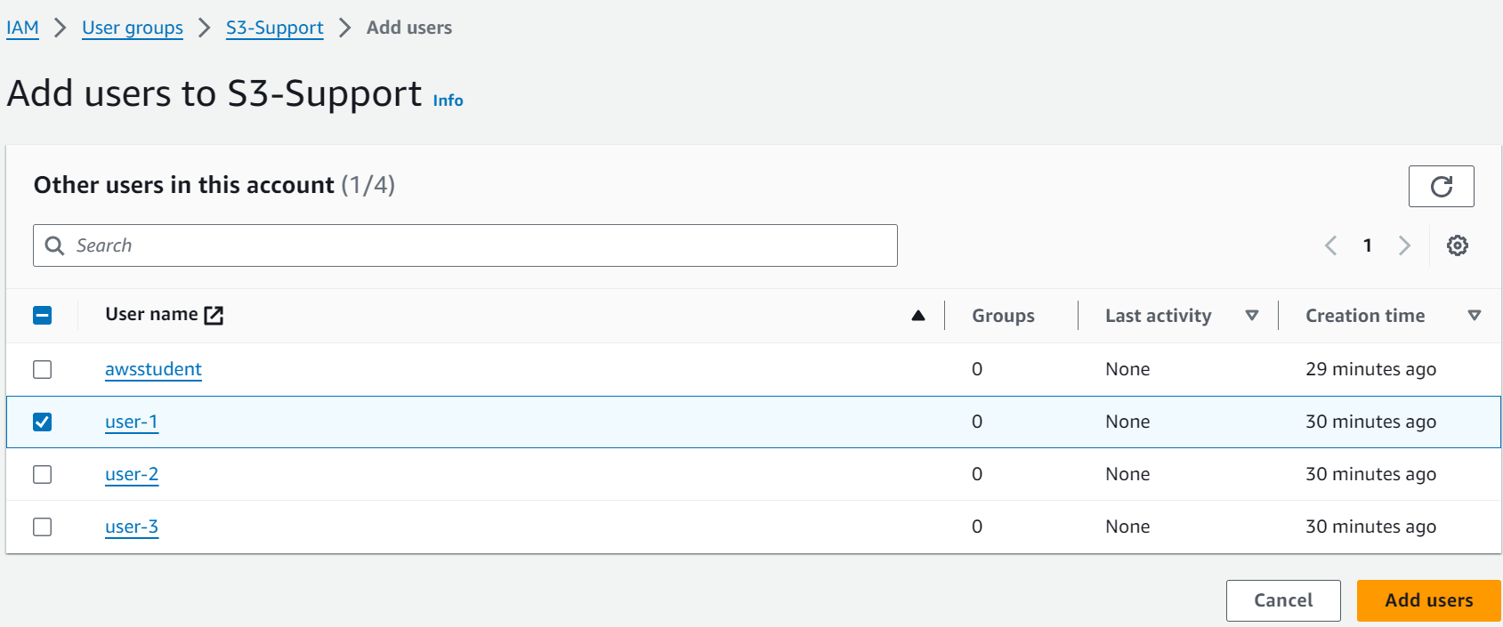

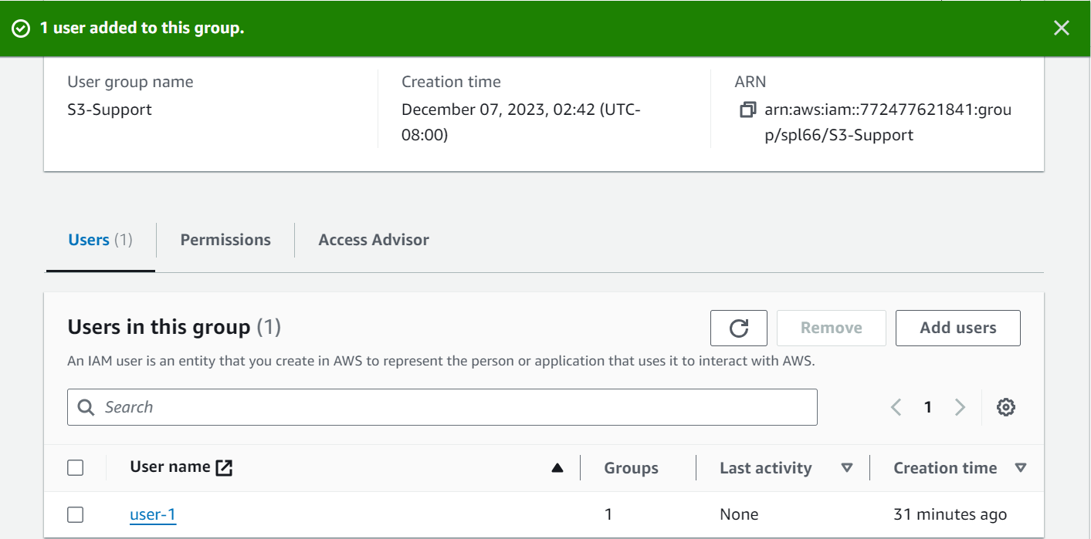

Step 11: Repeat steps 9 and 10 to add user-2 to the EC2-Support group and user-3 to the EC2-Admin group. Each group should now have 1 User assigned in the Users column.

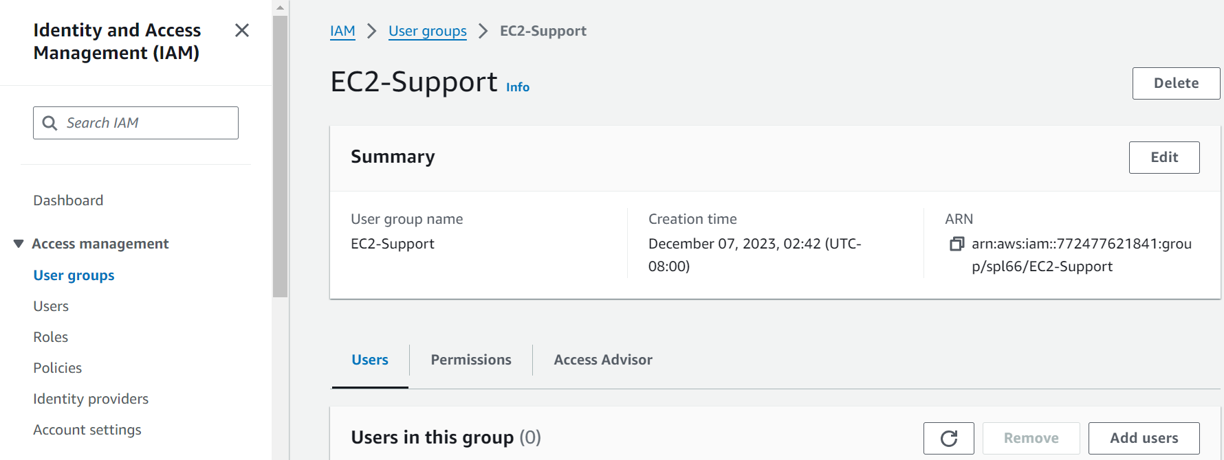

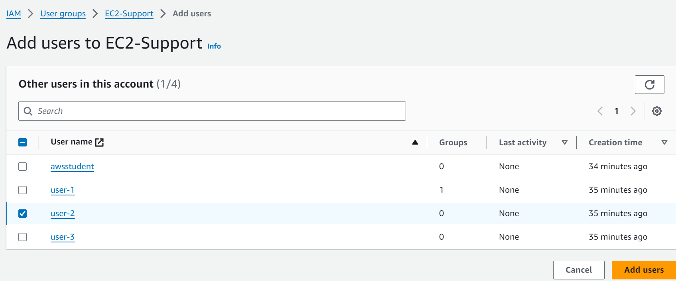

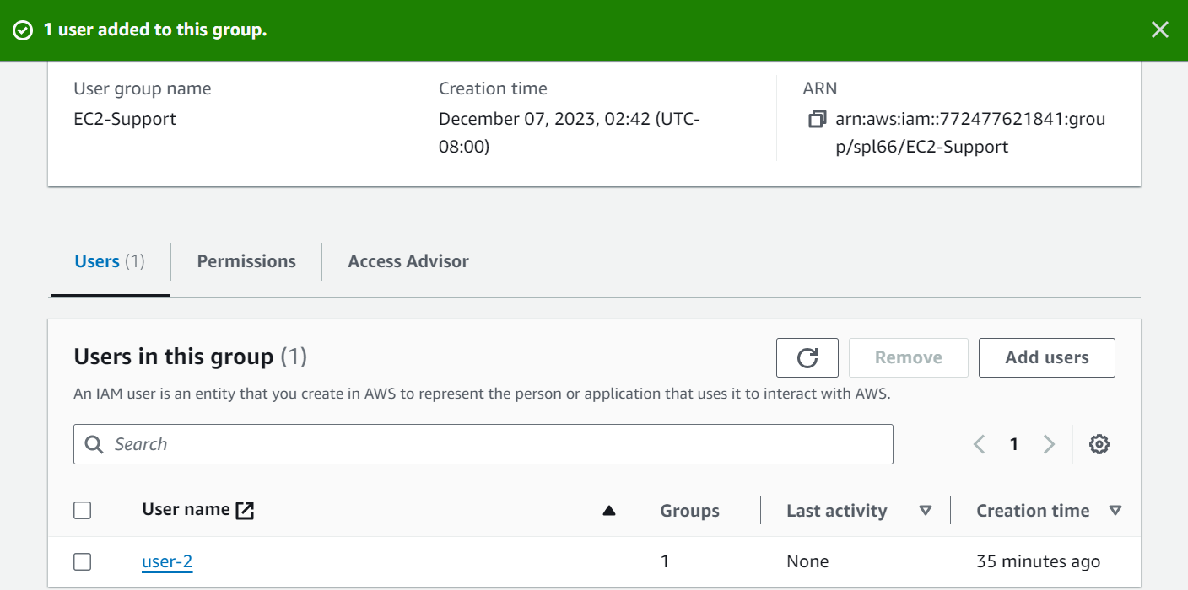

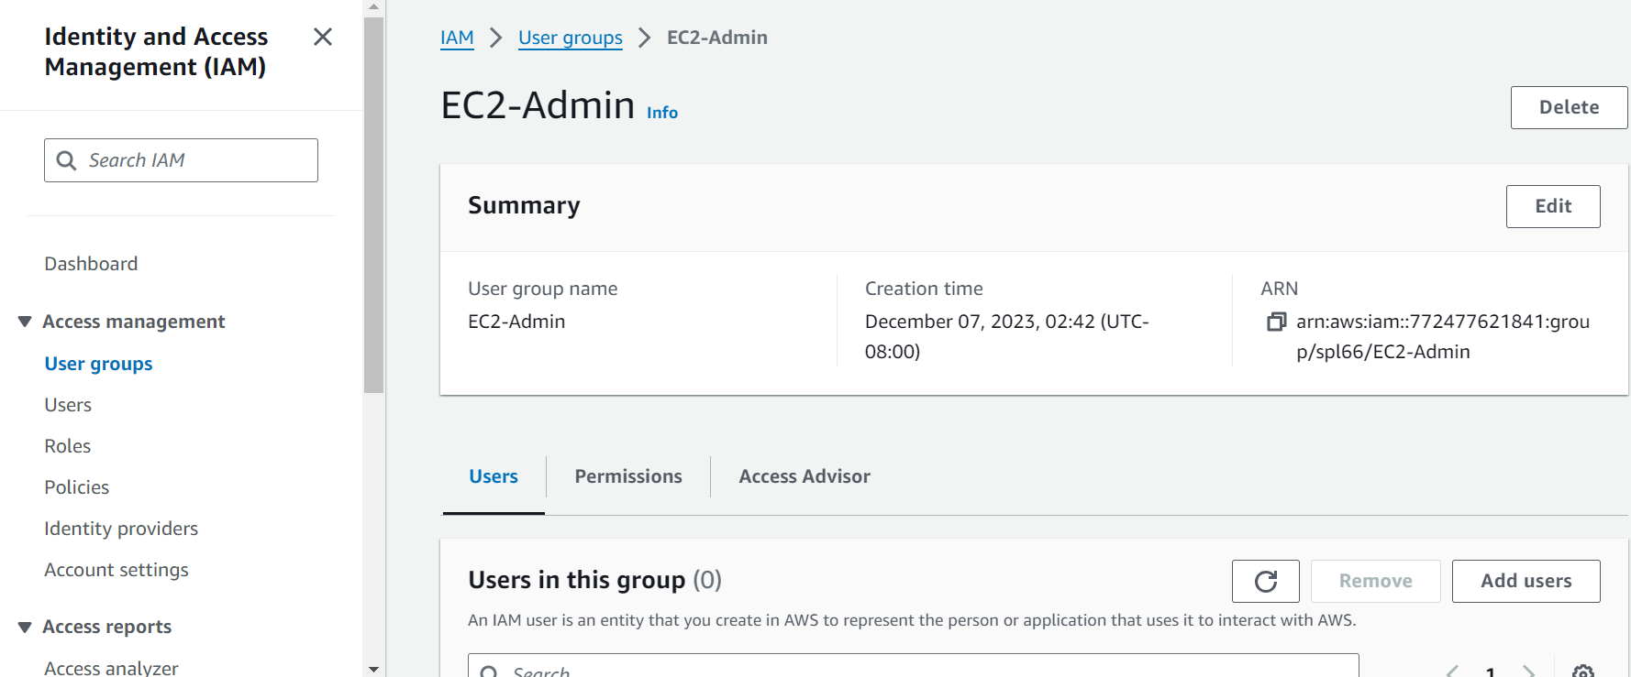

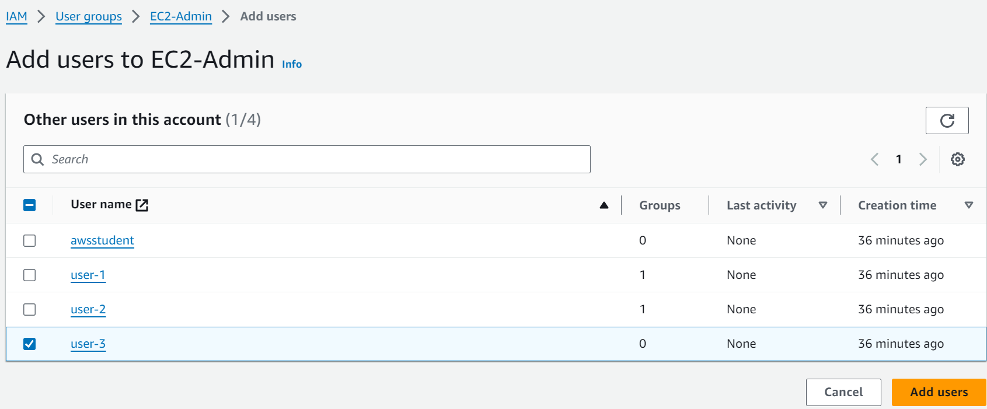

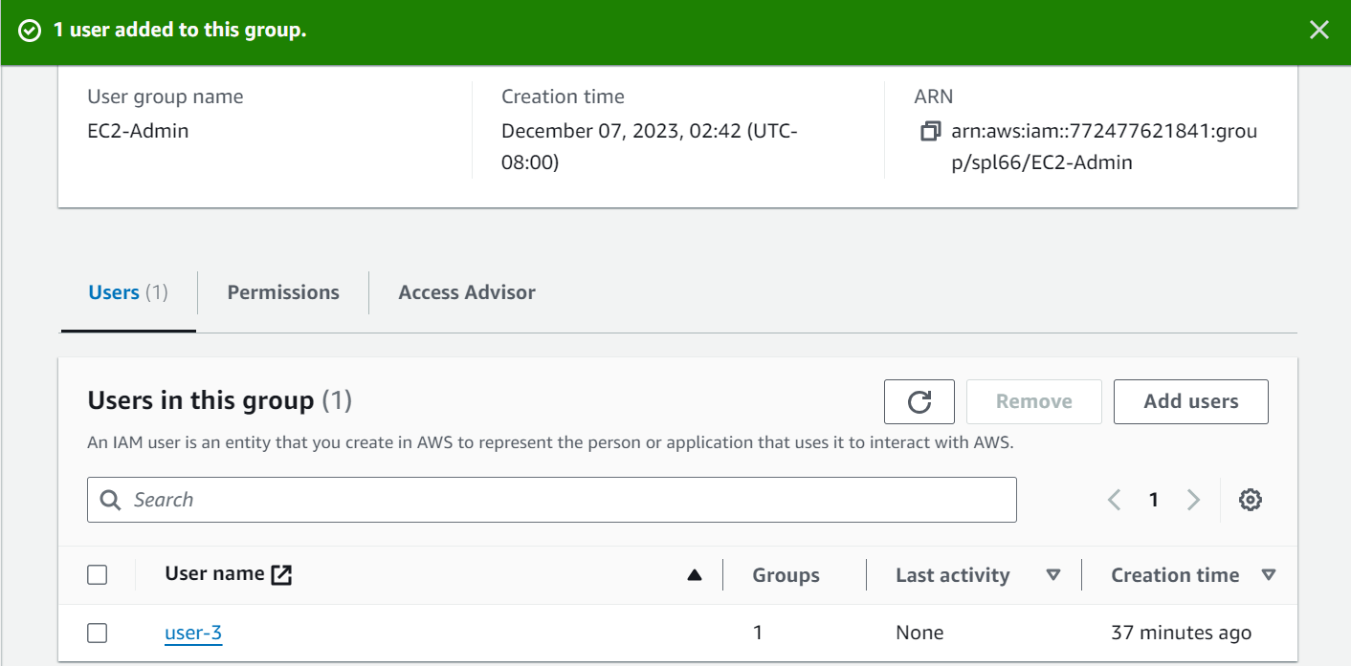

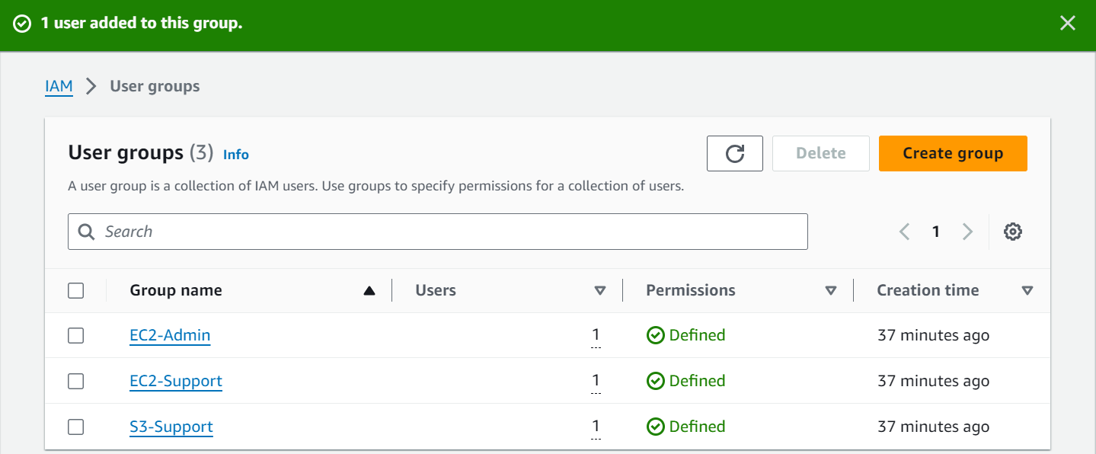

Step 12: In the left sidebar, select Dashboard. Displayed on the right is an IAM users sign-in link and copy the Sign-in URL for IAM user in this account to your clipboard.

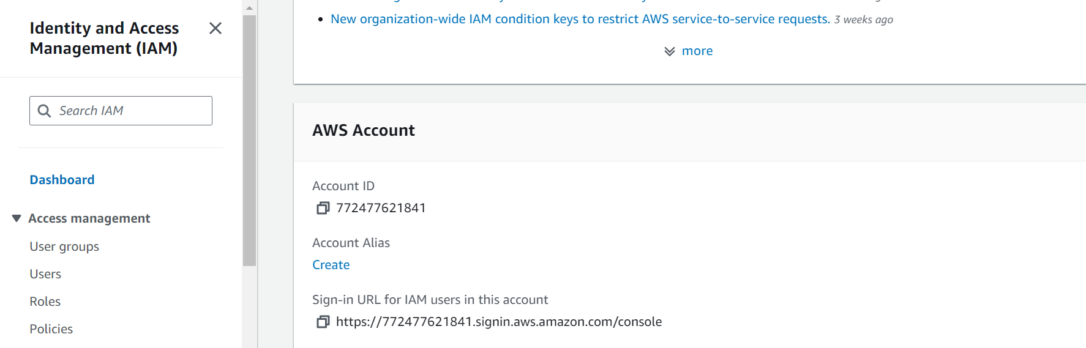

Step 13: Create a private (Incognito) window. Paste the IAM users sign-in link and press Enter.

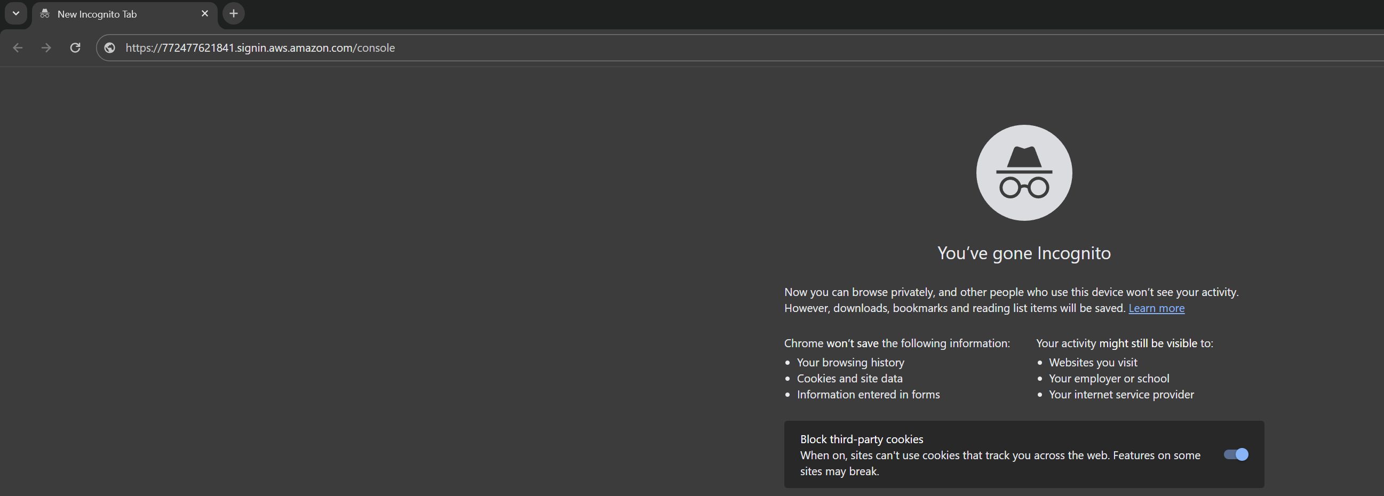

Step 14: Sign in using – IAM user name: user-1 and Password: Lab-Password1

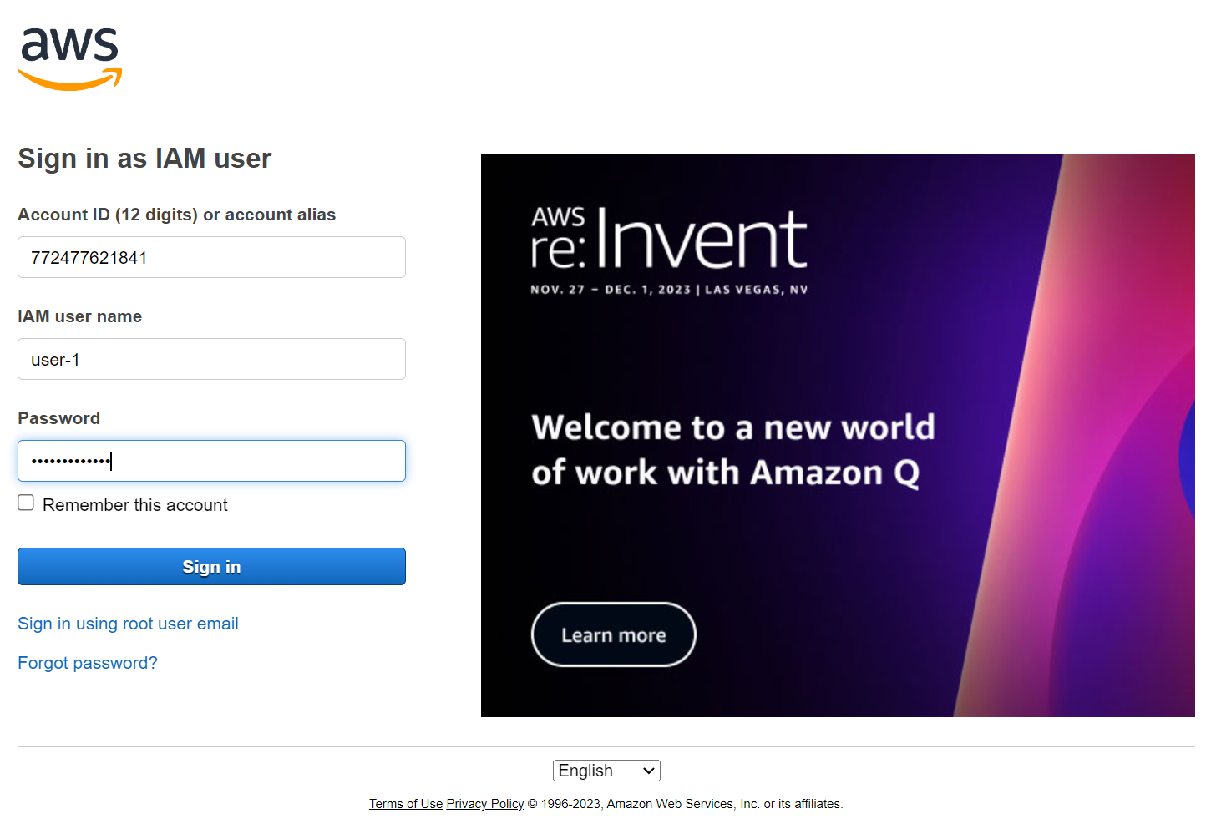

Step 15: Under the Services menu, select S3. Choose the name of the bucket existing in the account and observe the contents.

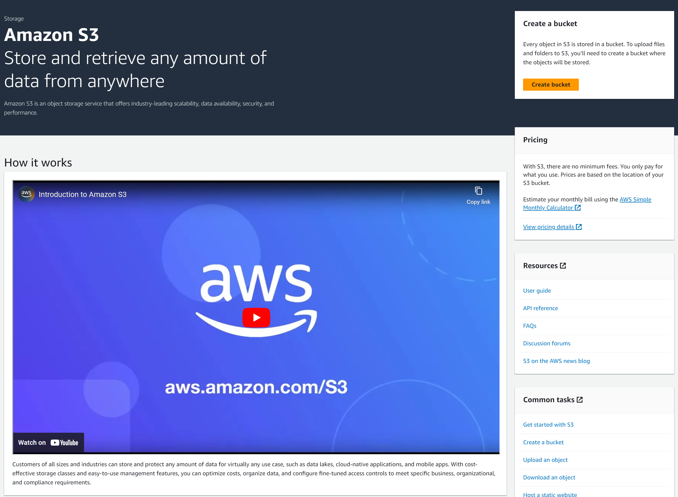

Step 16: Under the Services menu, select EC2. Then in the left sidebar select Instances. (You should see a message stating, “You are not authorized to perform this operation”)

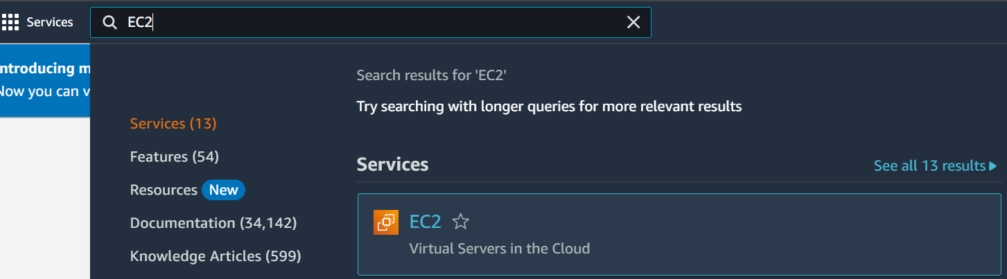



Step 17: Sign user-1 out of the AWS Management Console – Select user-1 at the top of the screen and choose Sign Out.

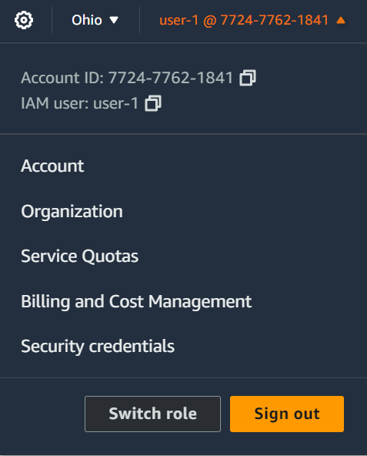

Step 18: Paste the IAM users sign-in link into your private browser tab and press Enter.



Step 19: Sign in using – IAM user name: user-2 and Password: Lab-Password2

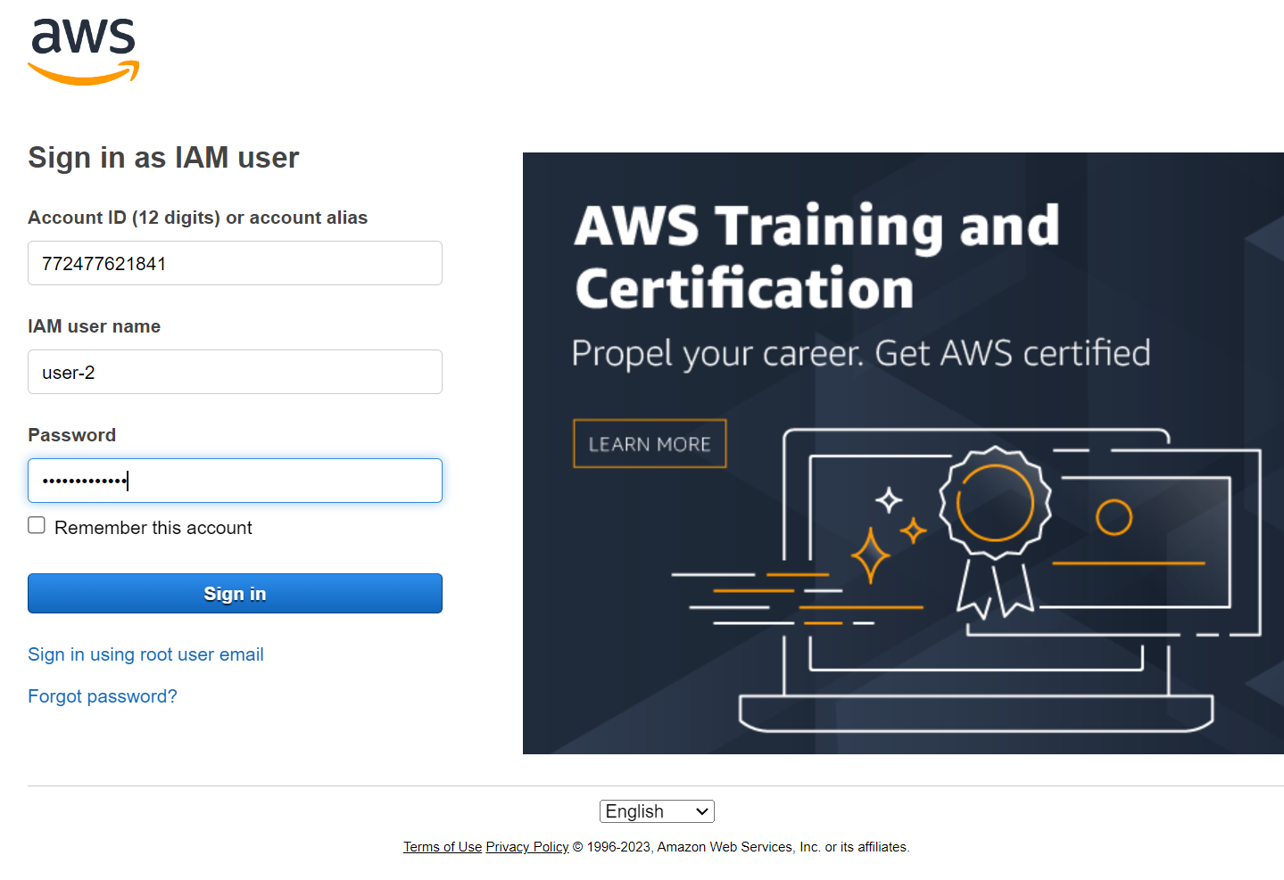

Step 20: Under the Services menu, select EC2. In the left sidebar, select Instances and choose the instance named LabHost

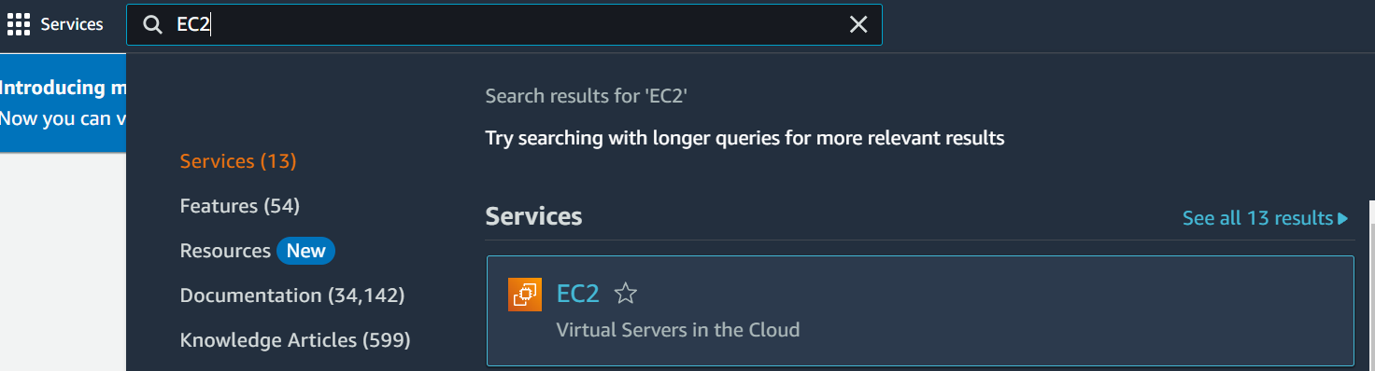



Step 21: Under the Instance State menu in the top right corner, choose Stop Instance. In the Stop Instance window, click Stop. (There will be an error stating, “You are not authorized to perform this operation”) Click the X to close the “Failed to stop the instance” message.





Step 22: Under the Services menu, select EC2. (There will be a message stating, “You don’t have permissions to list buckets”)



Step 23: Sign user-2 out of the AWS Management Console – Select user-2 at the top of the screen and choose Sign Out.



Step 24: Paste the IAM users sign-in link into your private browser tab and press Enter.



Step 25: Sign in using – IAM user name: user-3 and Password: Lab-Password3



Step 26: Under the Services menu, select EC2. In the left sidebar, select Instances and choose the instance named LabHost





Step 27: Under the Instance State menu, select Stop Instance. In the Stop Instance window, click Stop. (The instance will enter the stopping state and shutdown)





Step 28: Close your private browser tab.

Lab 2: Build Your VPC and Launch a Web Server

Step 1: At the top of the screen, search for and select VPC in the search box to open the VPC console. Verify that N. Virginia (us-east-1) is the selected region.

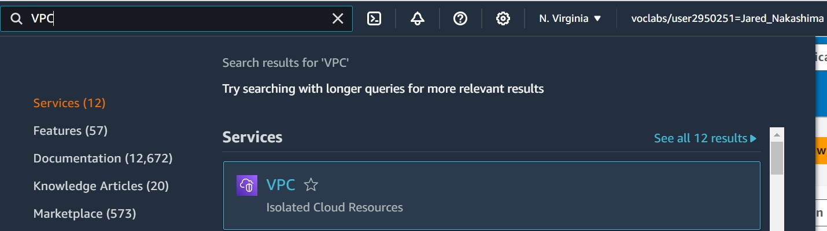

Step 2: Click on Create VPC. Configure VPC details as follows –

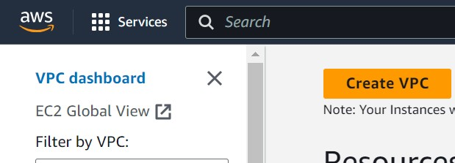

* Select VPC and more.

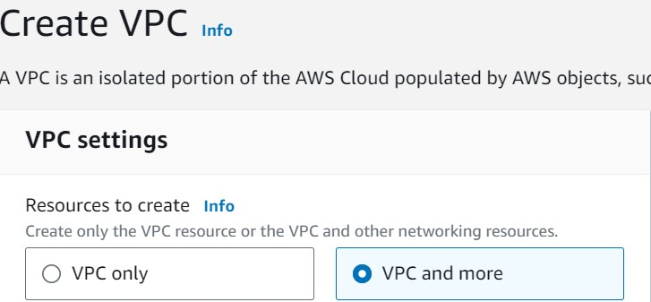

* Under Name tag auto-generation, keep Auto-generate selected, but change value from project to lab.

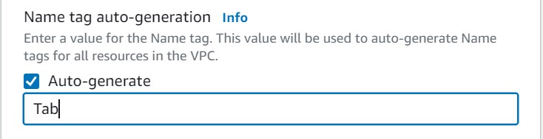

* Keep IPv4 CIDR block set to 10.0.0.0/16

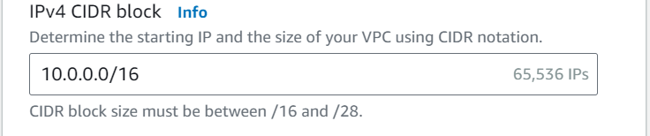

* Choose 1 for Number of Availability Zones.

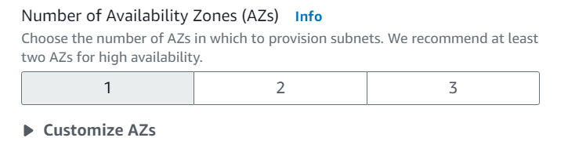

* Keep Number of public subnets to 1

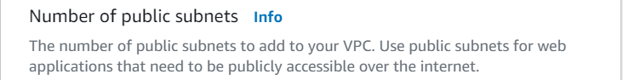



* Keep Number of private subnets to 1

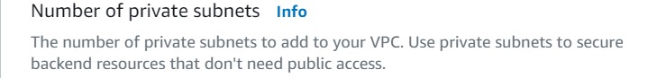



* Expand the Customize subnets CIDR blocks section: Change Public subnet CIDR block in us-east-1a to 10.0.0.0/24; Change Private subnet CIDR block in us-east-1a to 10.0.1.0/24

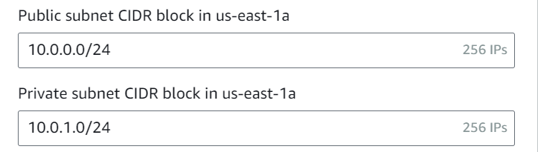

* Set Nat gateways to In 1 AZ

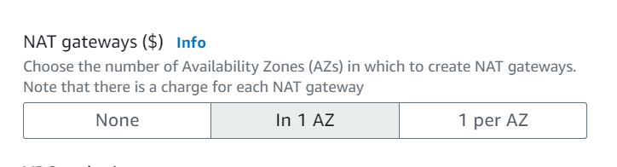

* Set VPC endpoints to None

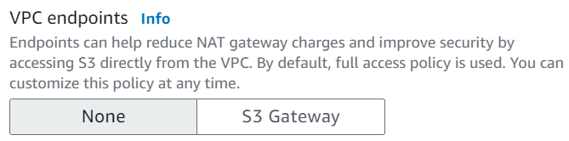

* Have DNS hostnames and DNS resolution remain enabled.

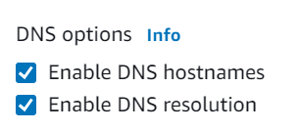

Step 3: Using the Preview panel on the right, confirm the configured settings. Then scroll to the bottom of the screen and select Create VPC. (Wait until all resources are created before moving on to the next step)

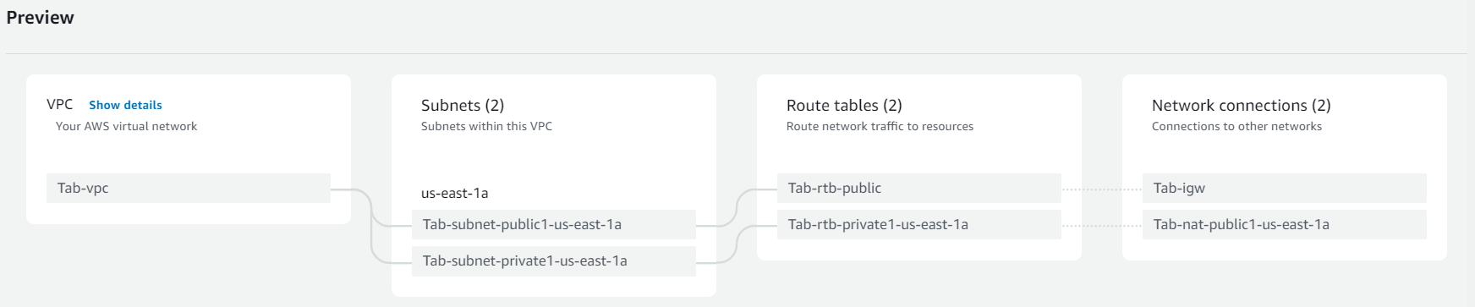

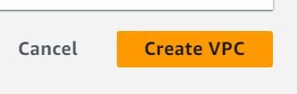

Step 4: Once created, select View VPC.

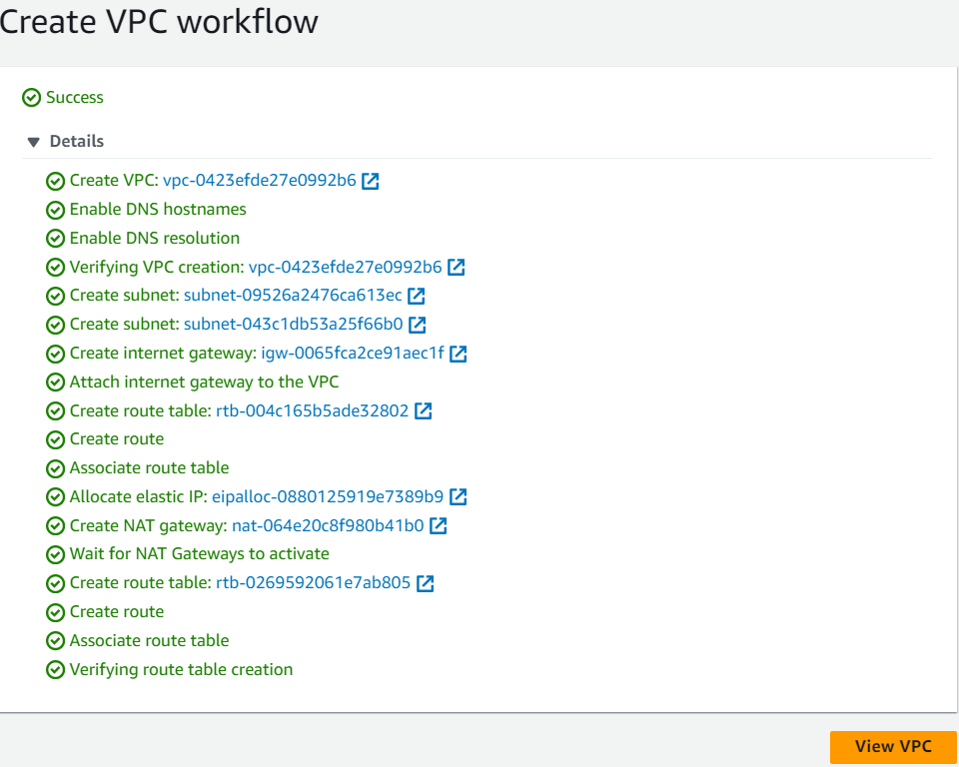

Step 5: In the left sidebar, select Subnets. You will first create a second *public* subnet.

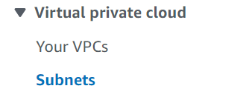

Step 6: Click Create Subnet and configure as follows –

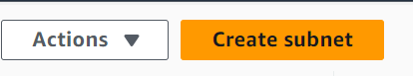

* VPC ID: lab-vpc (choose from menu)

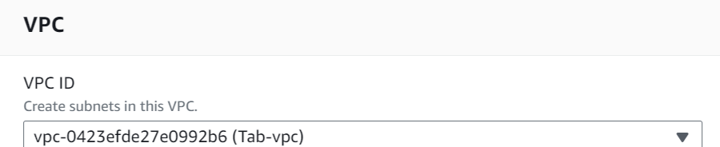

* Subnet name: lab-subnet-public2

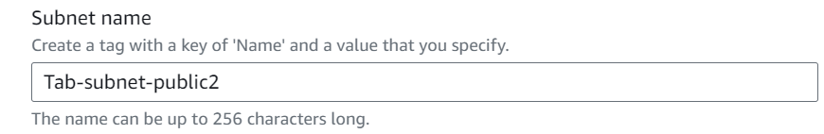

* Availability Zone: Choose the *second* Availability Zone from the menu

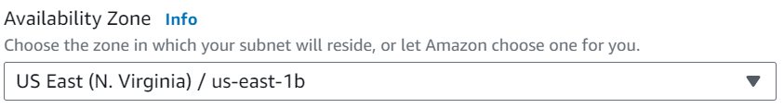

* IPv4 subnet CIDR block: 10.0.2.0/24

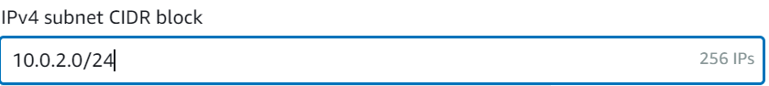

Step 7: Select Create Subnet. (The second *public* subnet has been created) You will now generate a second *private* subnet.

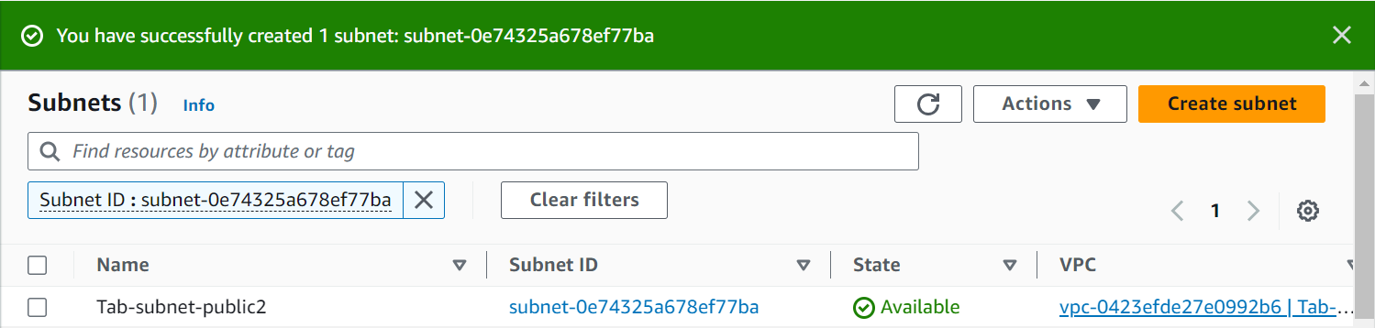

Step 8: Click Create Subnet and configure as follows –



* VPC ID: lab-vpc (choose from menu)

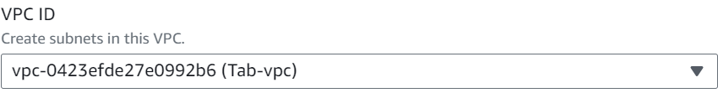

* Subnet name: lab-subnet-private2

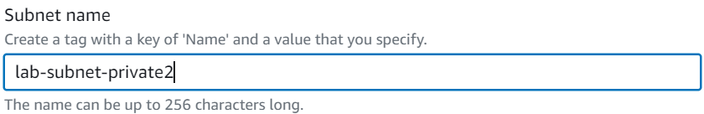

* Availability Zone: Choose the *second* Availability Zone from the menu

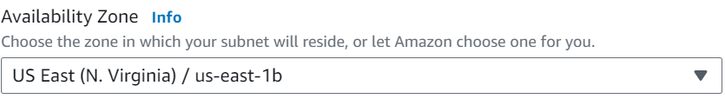

* IPv4 subnet CIDR block: 10.0.3.0/24

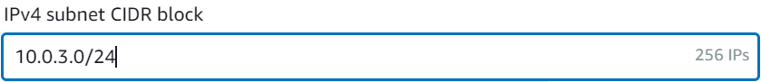

Step 9: Select Create Subnet. (The second *private* subnet has been created) Then in the left sidebar, select Route Tables.

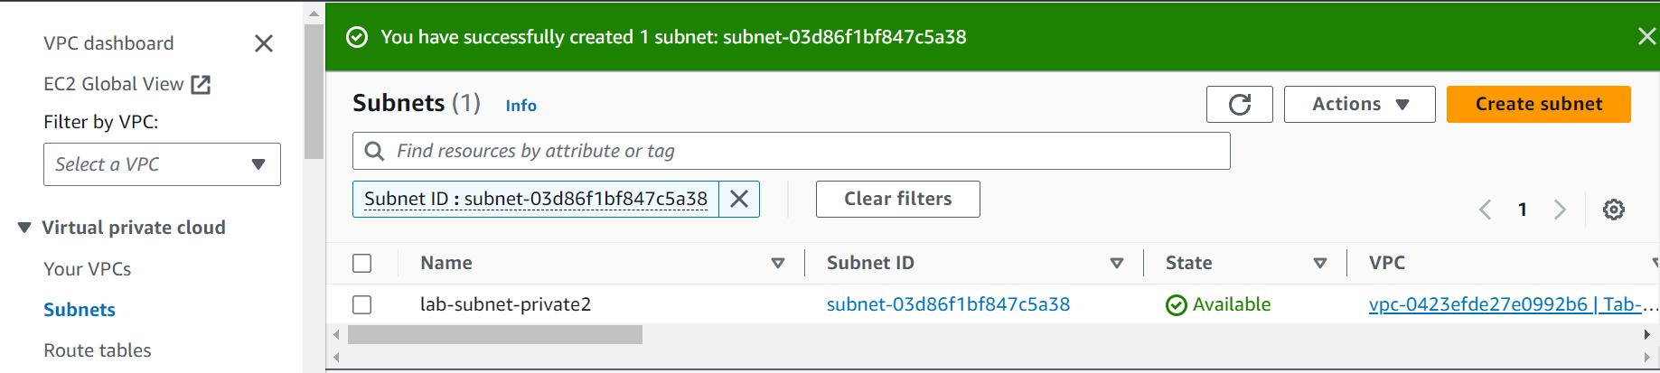

Step 10: Select the lab-rtb-private1-us-east-1a route table. In the lower pane, select the Routes tab. (Notice that Destination 0.0.0.0/0 is set to Target nat-xxxxxxxx, meaning traffic destined for the internet (0.0.0/0) will be sent to the Nat Gateway first)

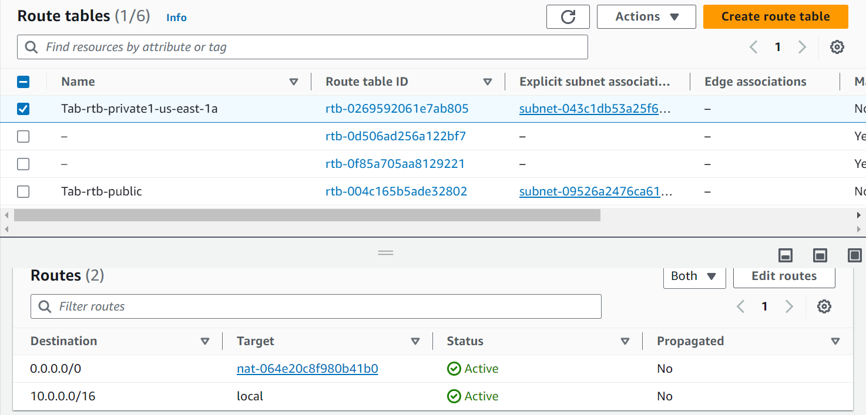

Step 11: Select the Subnet Associations tab. In the Explicit subnet associations panel, select Edit Subnet Associations.

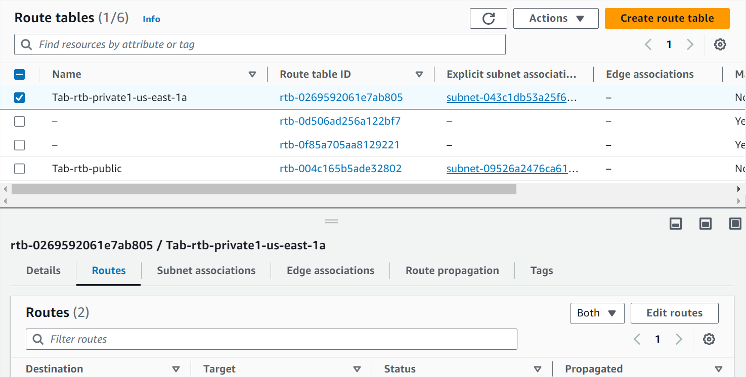

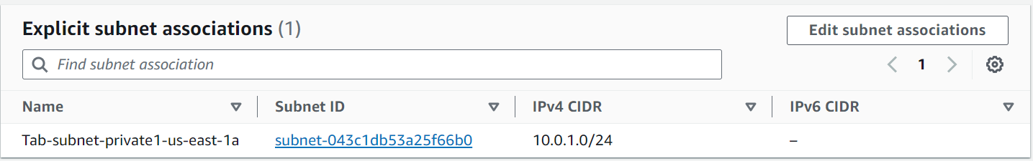

Step 12: With lab-subnet-private1-us-east-1a still selected, also select lab-subnet.private2 and choose Save Associations.

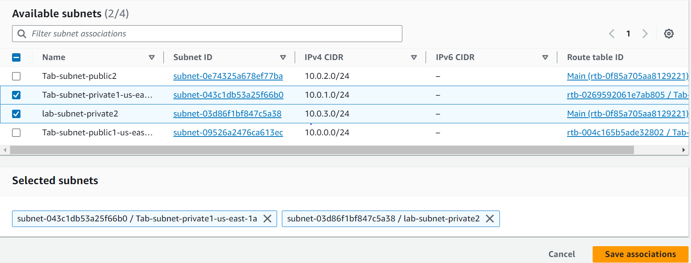

Step 13: Select the lab-rtb-public route table. (deselect any other subnets) In the lower pain select the Routes tab. (Notice that Destination 0.0.0.0/0 is set to Target igw-xxxxxxxx, meaning that internet-bound traffic will go straight to the internet via this Internet Gateway)

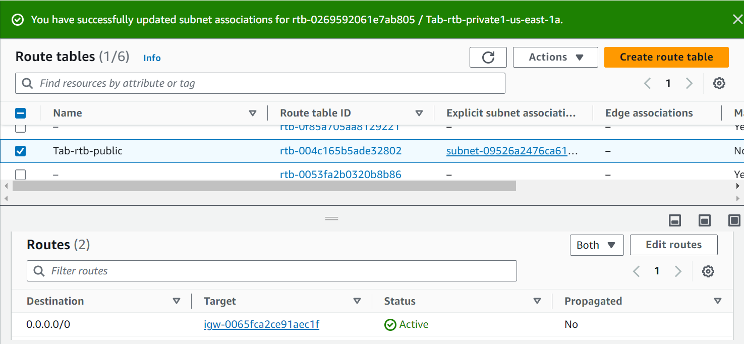

Step 14: Select the Subnet Associations tab. In the Explicit subnet associations panel, select Edit Subnet Associations.



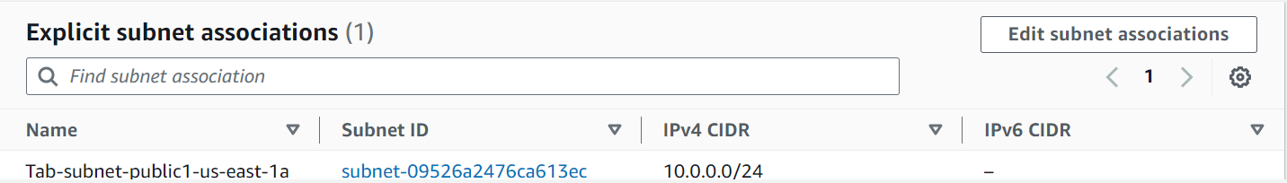

Step 15: With lab-subnet-public1-us-east-1a still selected, also select lab-subnet-public2 and choose Save Associations.

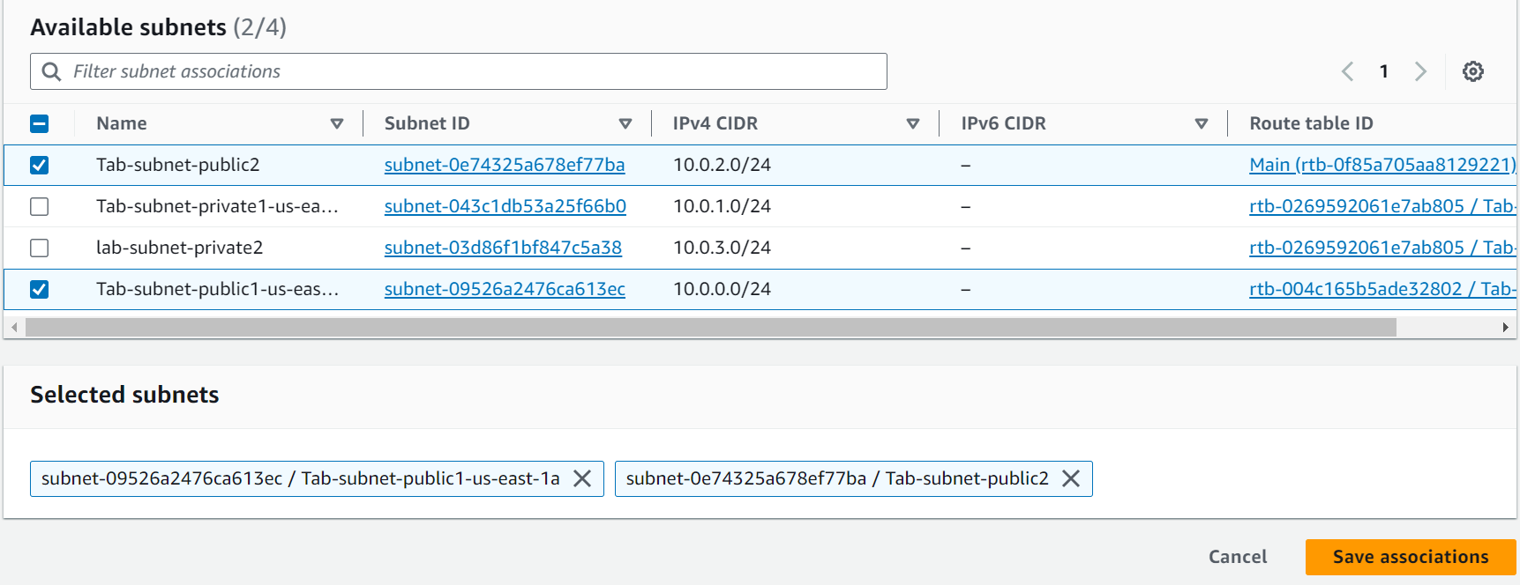

Step 16: In the left sidebar, select Security Groups.

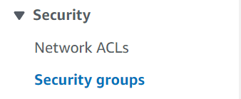

Step 17: Click on Create Security Group and configure as follows –

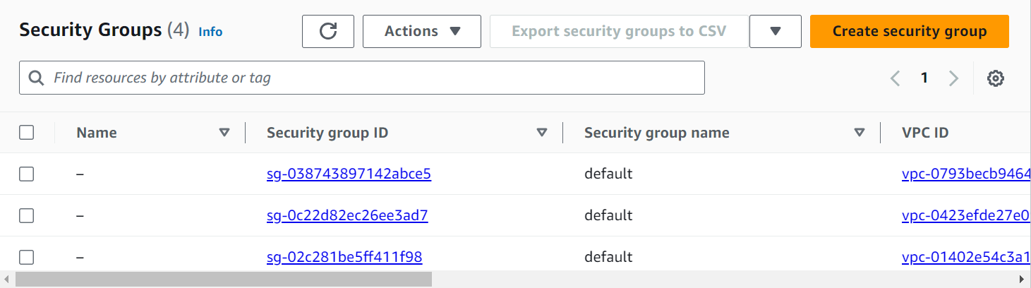

* Security group name: Web Security Group

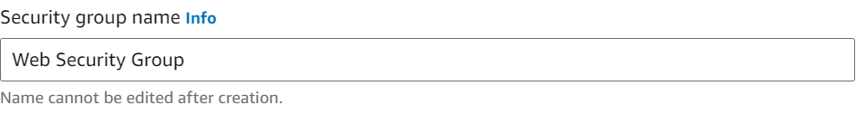

* Description: Enable HTTP access

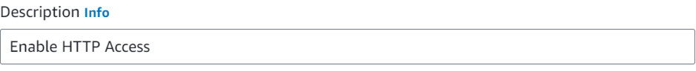

* VPC: Select the X to remove the currently selected VPC, and then choose lab-vpc

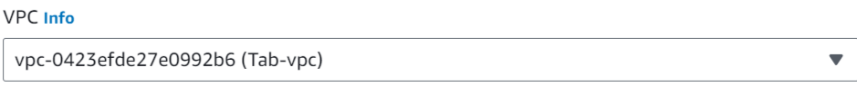

Step 18: In the Inbound Rules pane, select Add Rule. Configure the rule as follows –

* Type: HTTP
* Source: Anywhere-IPv4
* Description: Permit web requests

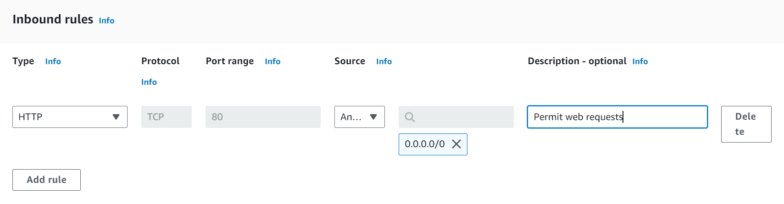

Step 19: Scroll to the bottom of the page and click on Create Security Group.



Step 20: At the top of the screen, in the search box, search for and select EC2 to open the console.

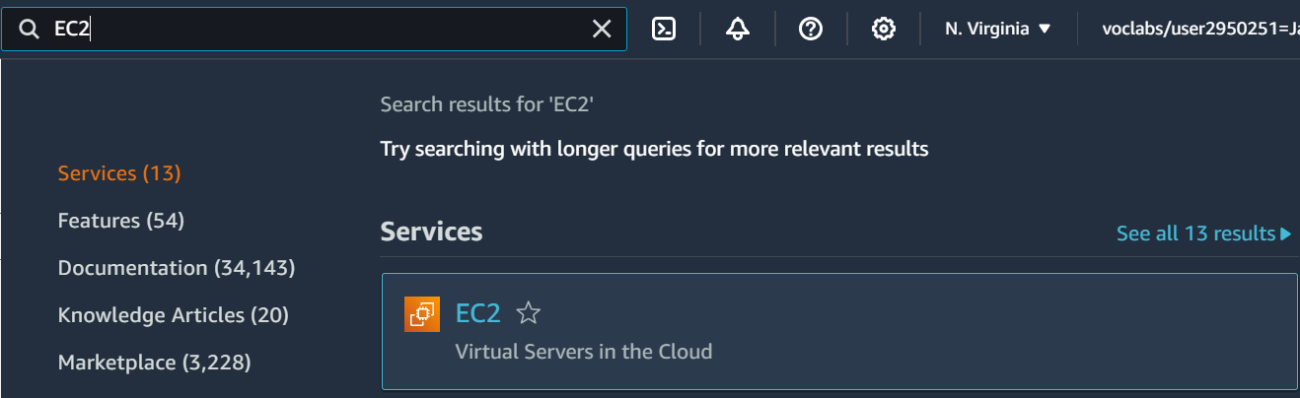

Step 21: Under the Launch Instance menu, select Launch Instance.



Step 22: Name the instance: Web Server 1

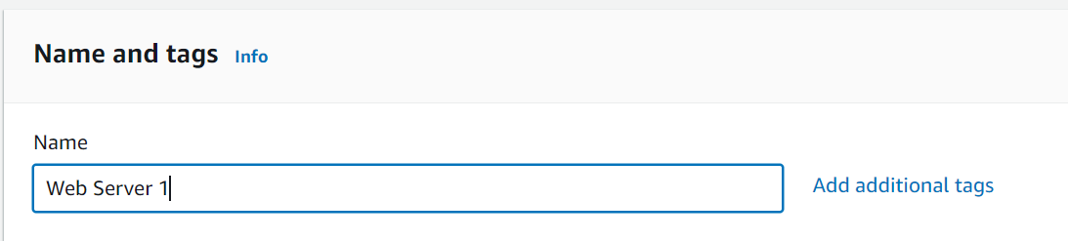

Step 23: In the list of available Quick Start AMIs, keep the default Amazon Linux and Amazon Linux 2023 AMI selected.

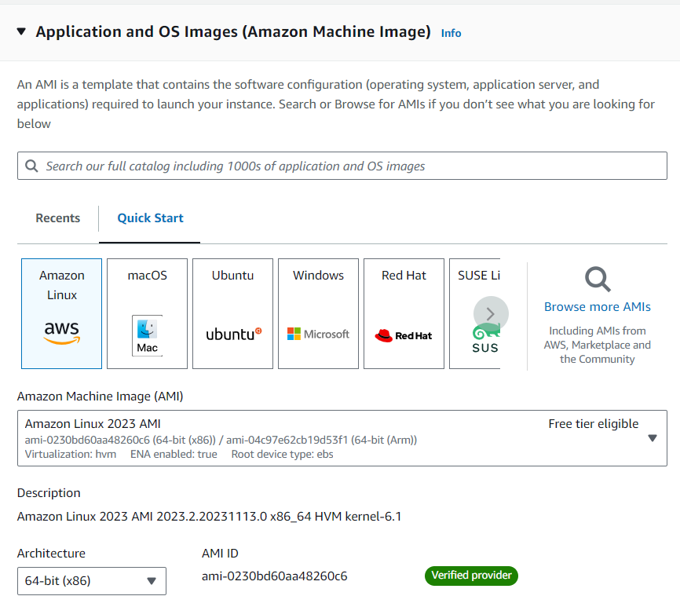

Step 24: Under Instance Type, keep the default t2.micro selected.

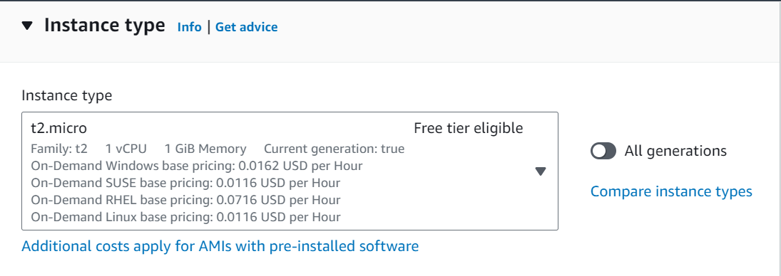

Step 25: In the Key Pair Name menu, choose vockey.

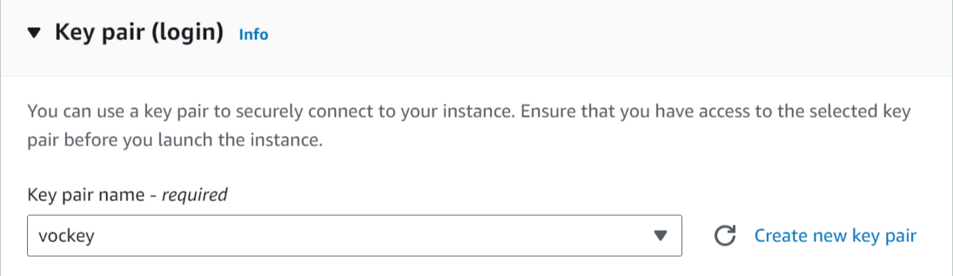

Step 26: In the Network settings, select Edit and configure –

* Network: lab-vpc
* Subnet: lab-subnet-public2
* Auto-assign public IP: Enable.
* Under Firewall (security groups), choose Select existing security group. For Common security groups, select Web Security Group.

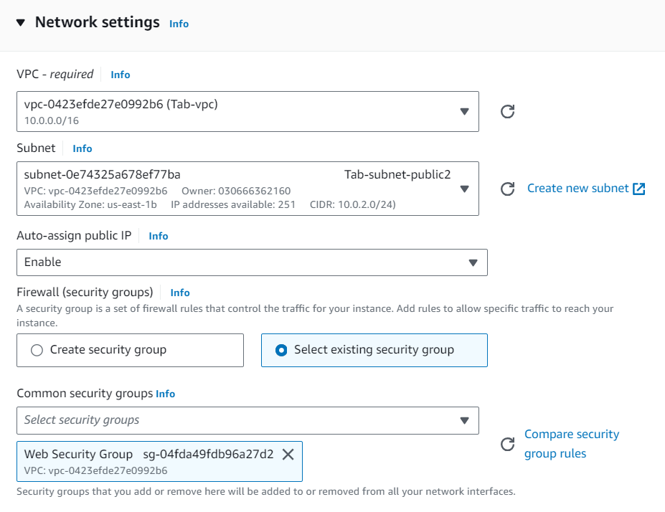

Step 28: Keep the default settings of the Configure storage section.

Step 29: Expand the Advanced details section. Scroll to the bottom of the page and copy the code shown into the User data box.

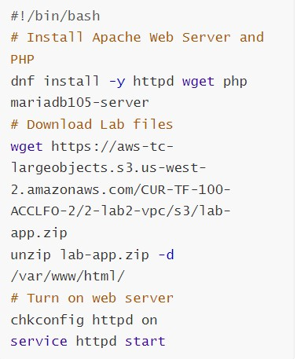

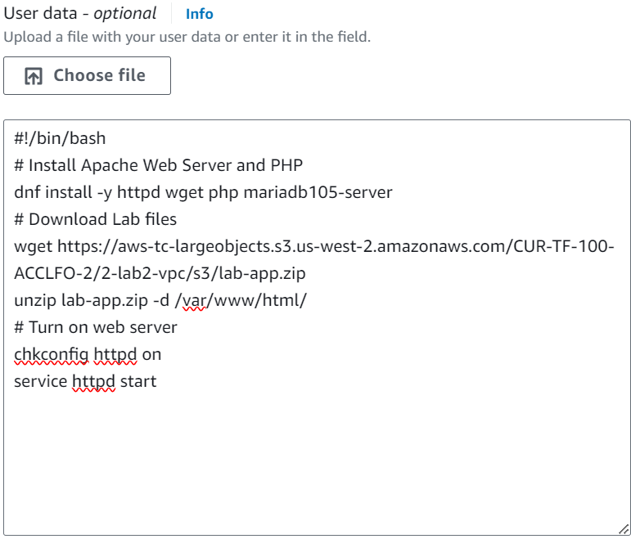

Step 30: On the right side of the screen, at the bottom of the Summary panel, select Launch Instance.

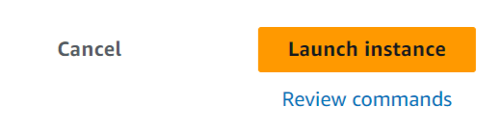

Step 31: Select View All Instances.

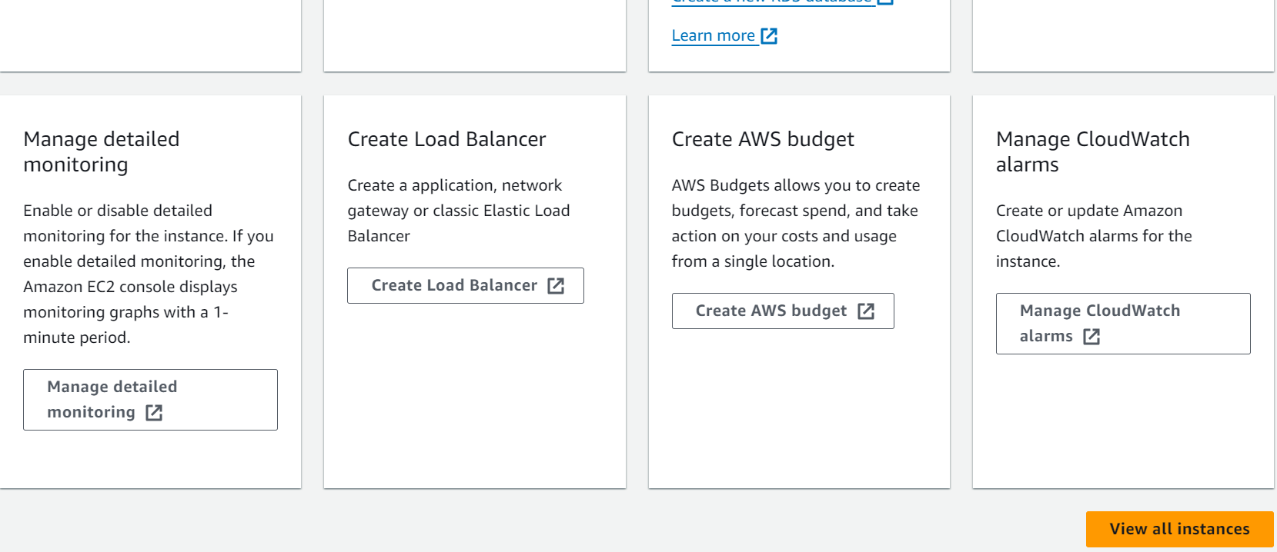

Step 32: Wait until Web Server 1 displays 2/2 checks passed in the Status Check column.

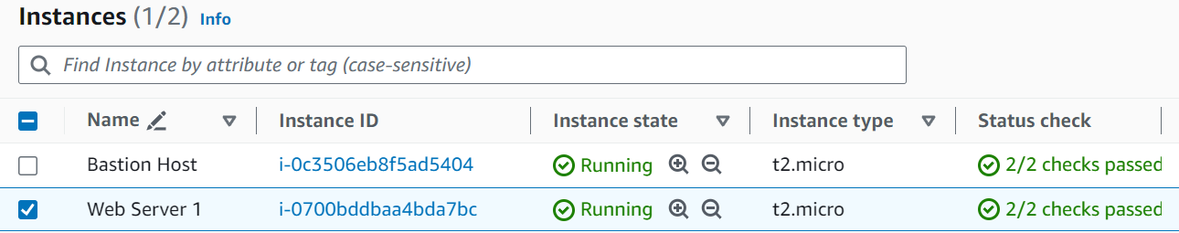

Step 33: Select Web Server 1 and copy the Public IPv4 DNS link in the Details tab.

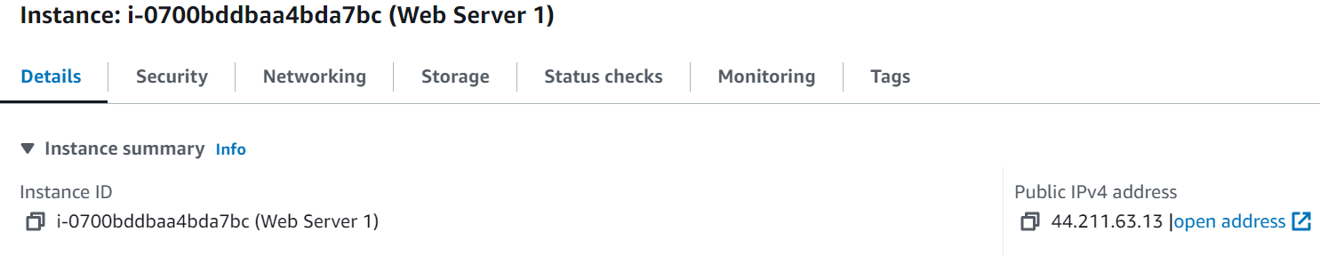

Step 34: Create a new web browser tab, paste the link into the search bar and press Enter. (You should see a web page displaying the AWS logo and instance meta-data values)



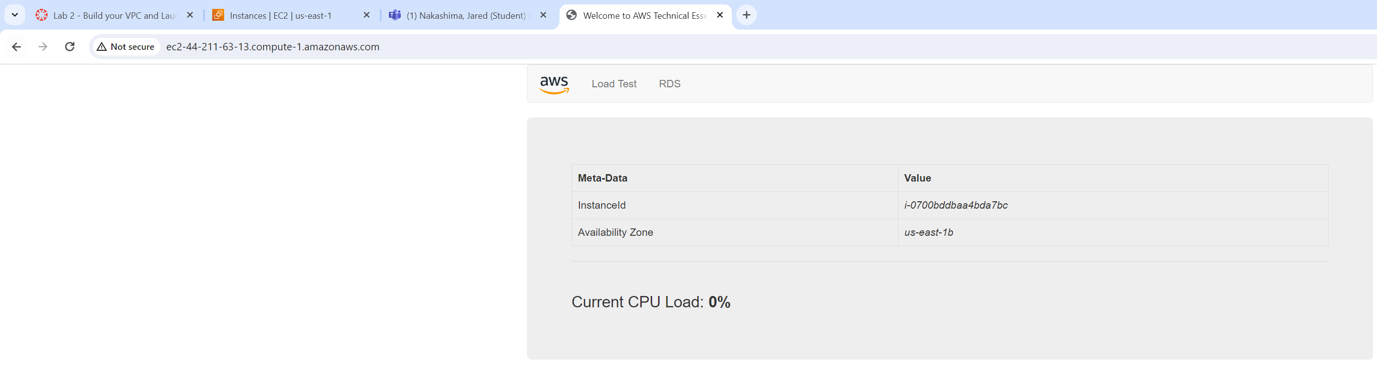

Lab 3: Introduction on to Amazon EC2

Step 1: In Management Console of AWS, select Services, choose Compute, and then choose EC2.

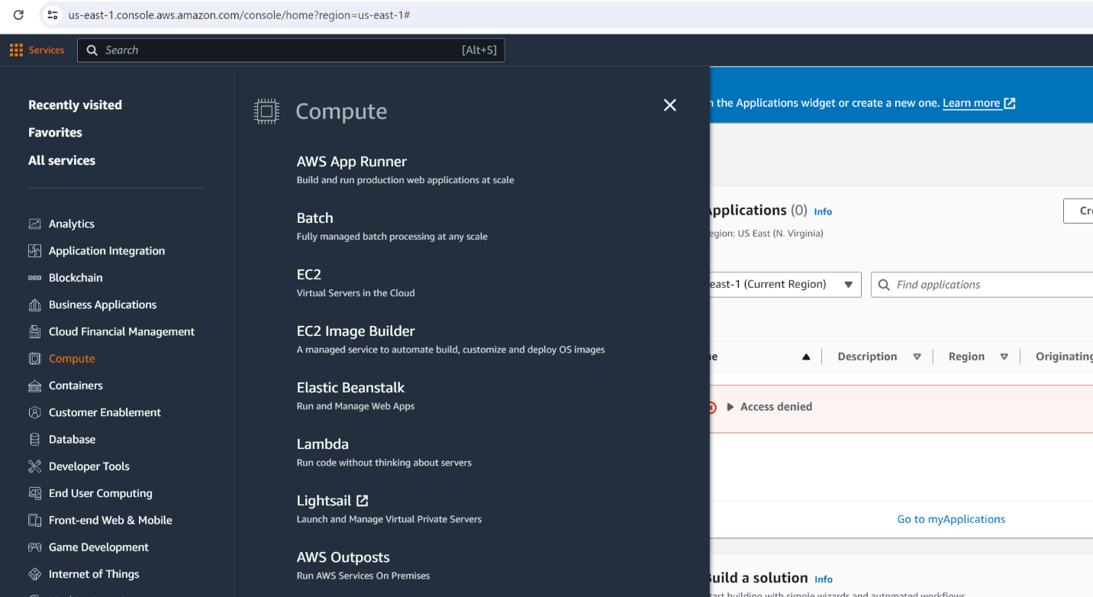

Step 2: On the EC2 Dashboard, select Launch instance from the Launch instance menu.’

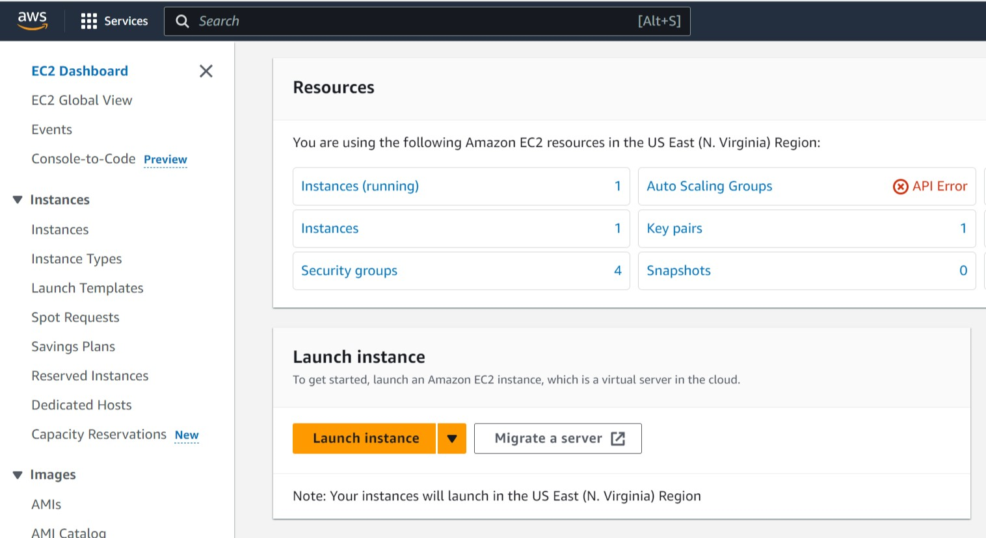

Step 3: Name the instance Web Server.

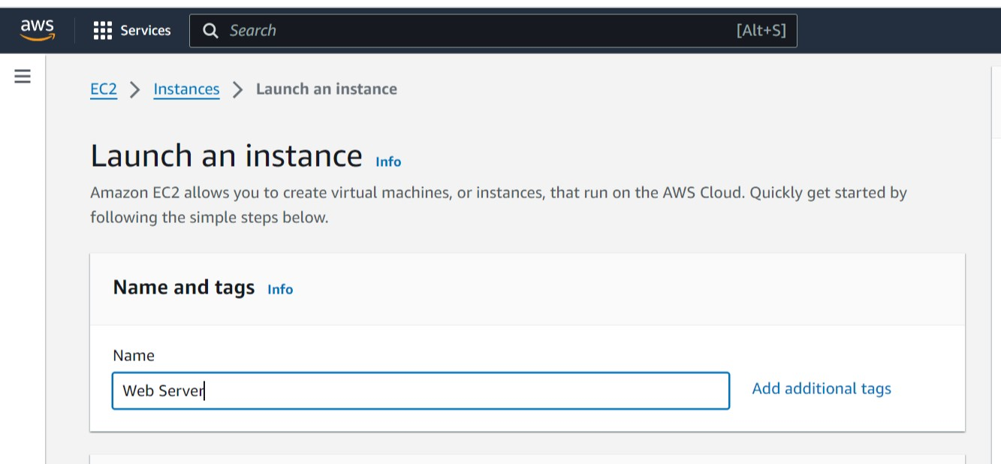

Step 4: Under Quick Start AMIs, keep default Amazon Linux AMI and default Amazon Linux 2023 AMI selected.

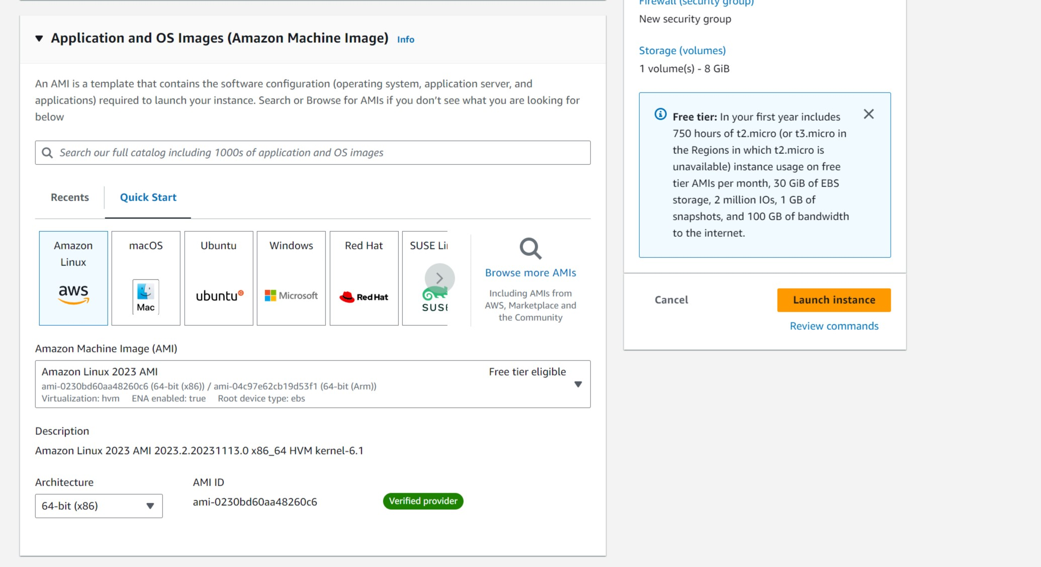

Step 5: Under the Instance Type panel, have selected the default t2.micro.

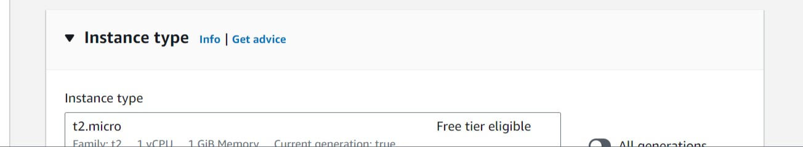

Step 6: Under Key Pair (login) panel, select vockey.

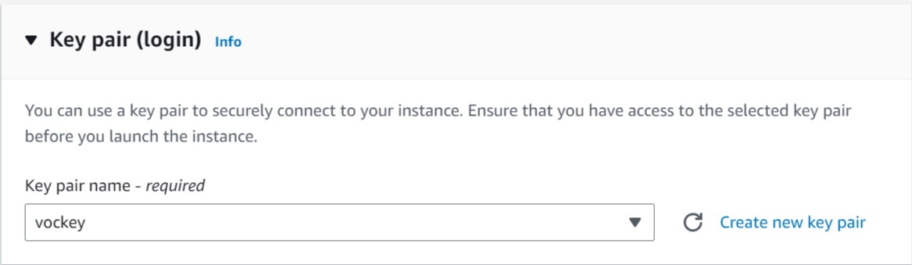

Step 7: Under Network Settings panel, select Lab VPC for your VPC. In the same panel, select Create Security Group. Configure the security group name: Web Server security group and the Description: Security group for my web server. Lastly, in Inbound Security Group Rules, remove any rules.

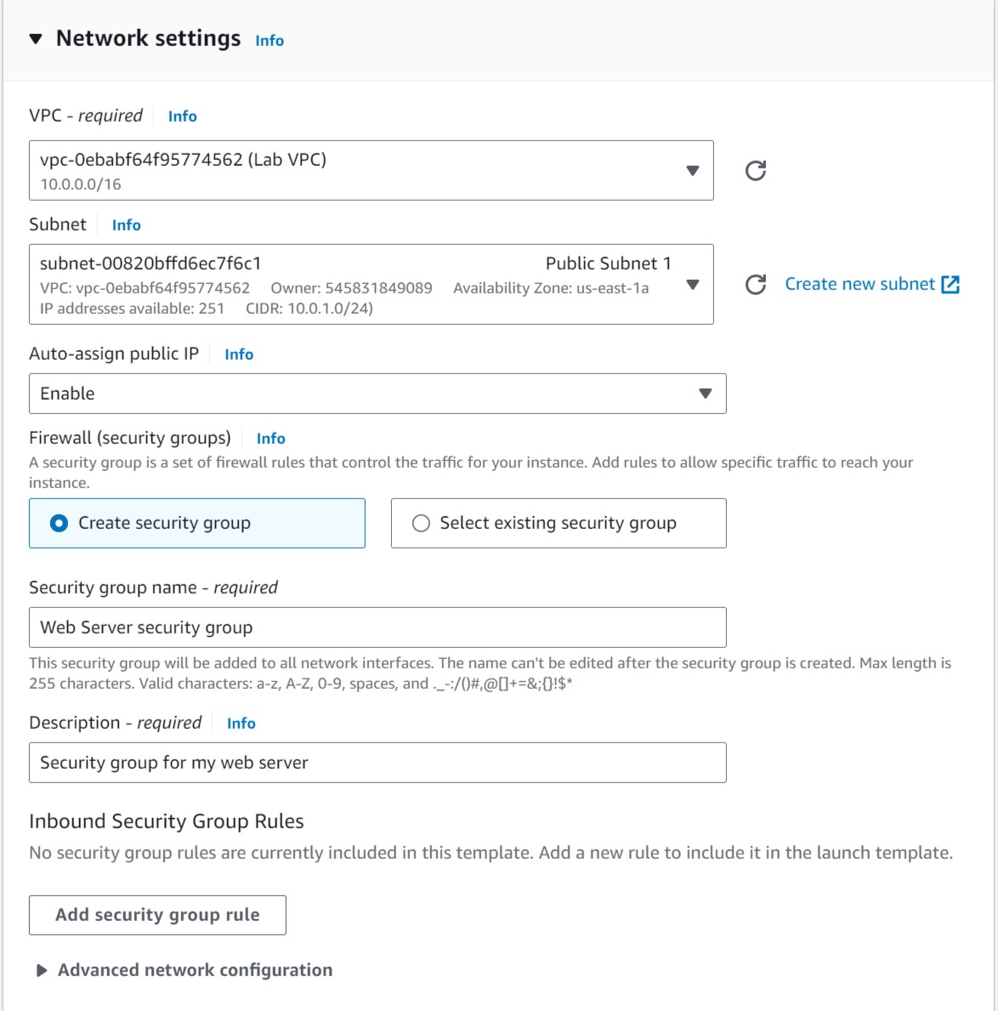

Step 8: Under Configure Storage panel, keep the default setting selected.

Step 9: Under Advanced Details panel, Enable Termination protection. At the bottom of the page, in User data box, copy and paste code below:

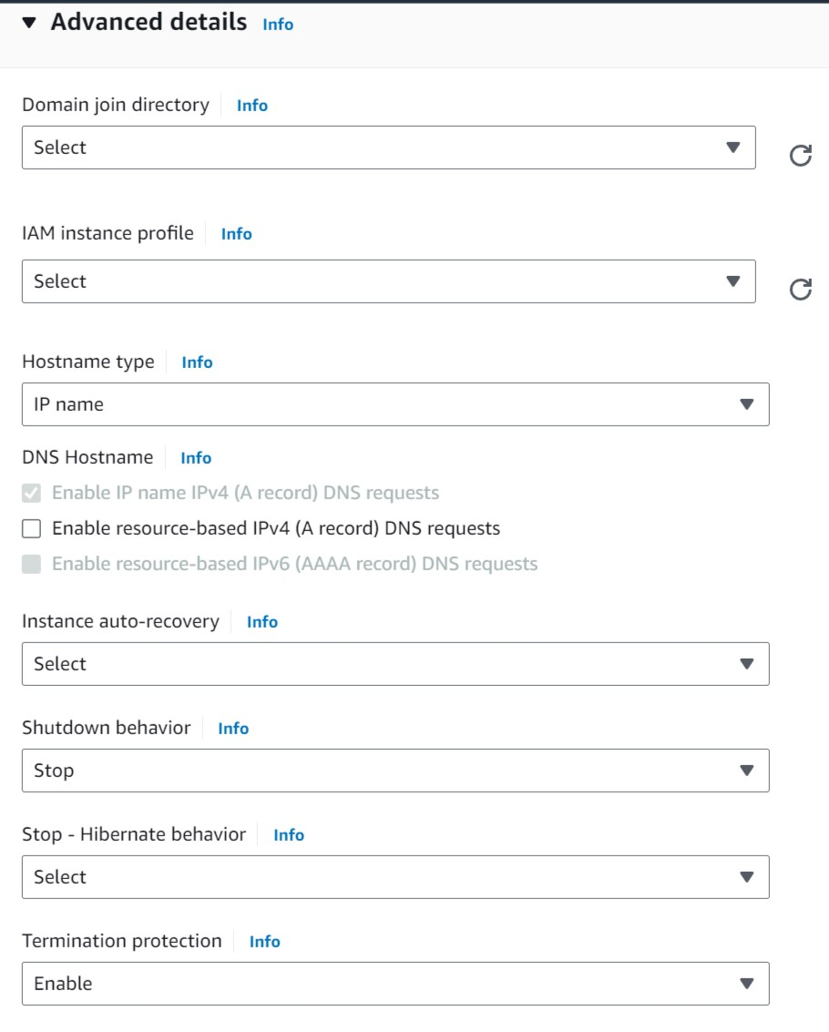

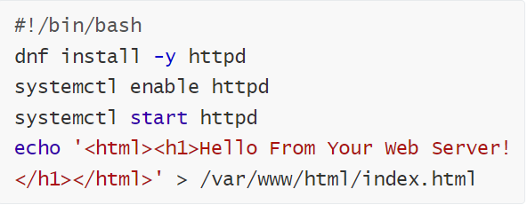

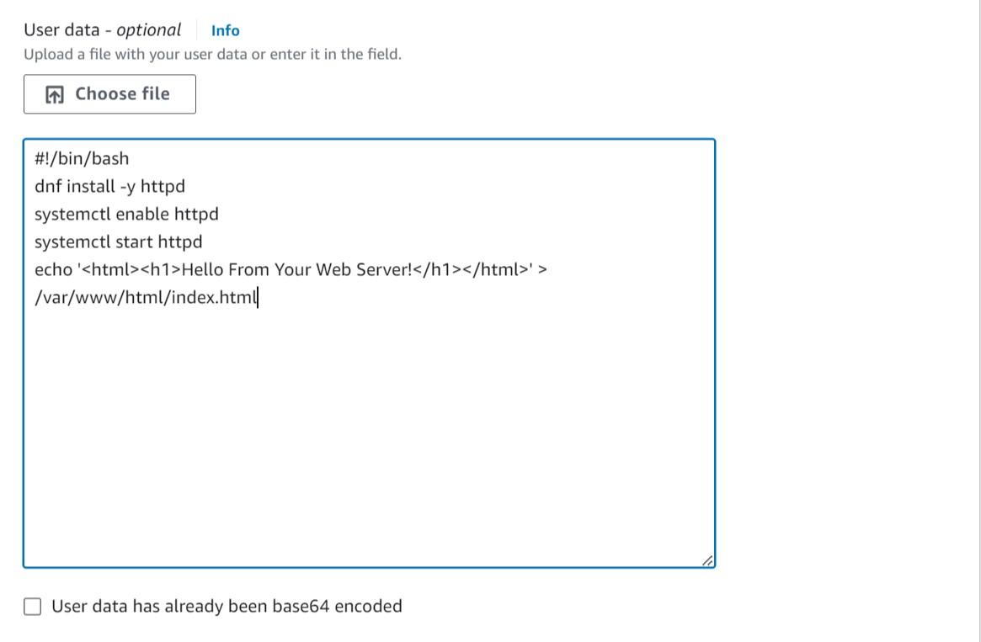

Step 10: On the right side of the page, at the bottom of the Summary Panel, select Launch Instance.

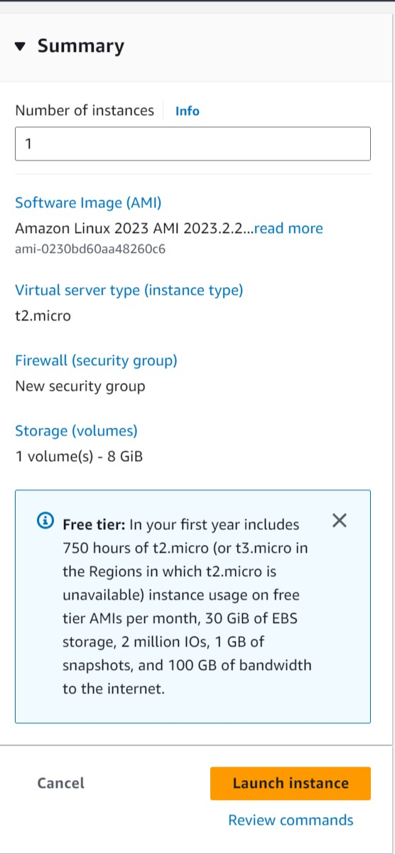

Step 11: After successfully launching your instance, select View all Instances. Choose Web Server from the list of instances, and under the Details tab, review the information shown.

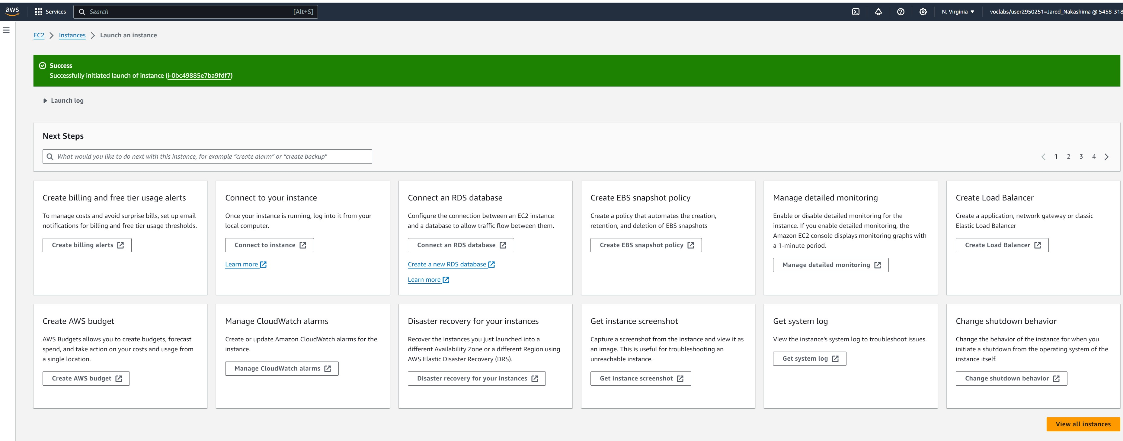

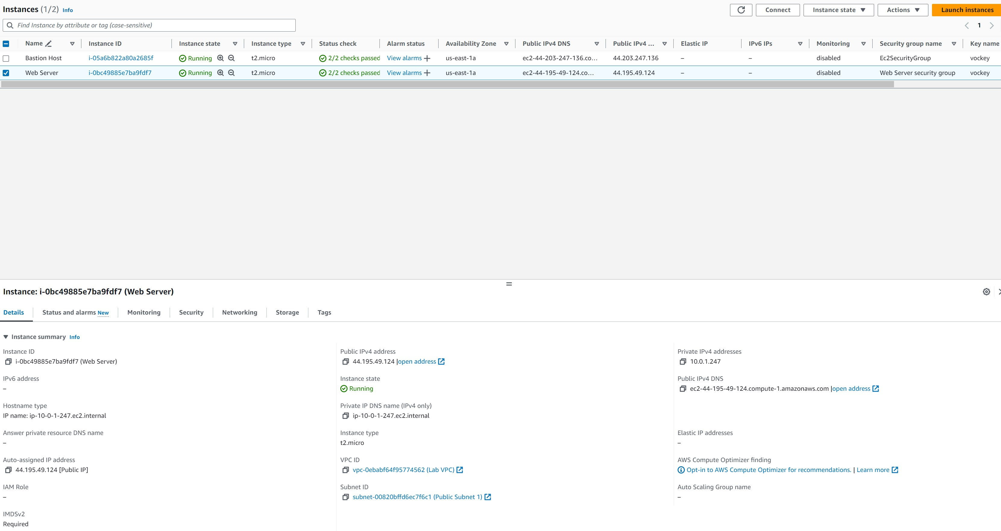

Step 12: See that your instance shows Instance State: Running and Status Checks: 2/2 checks passed.

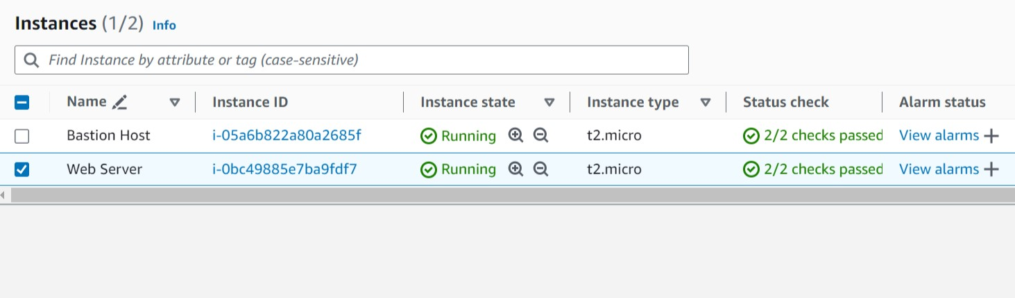

Step 13: Select the Status Checks tab (Using instance status monitoring, easily determine if Amazon EC2 has detected a problem that may prevent your instance from running applications).

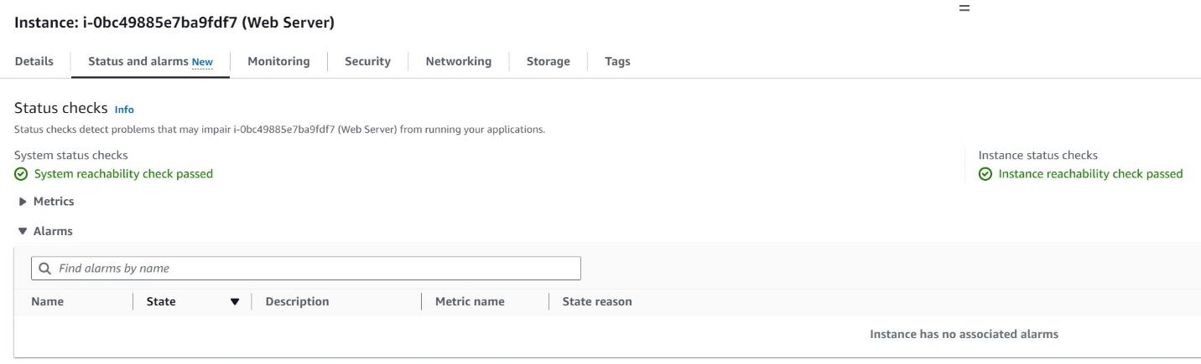

Step 14: Select the Monitoring tab. (The Monitoring tab shows Amazon CloudWatch metrics for your instance. You can select the three dots in a graph and choose Enlarge to see an expanded view of the selected metric)

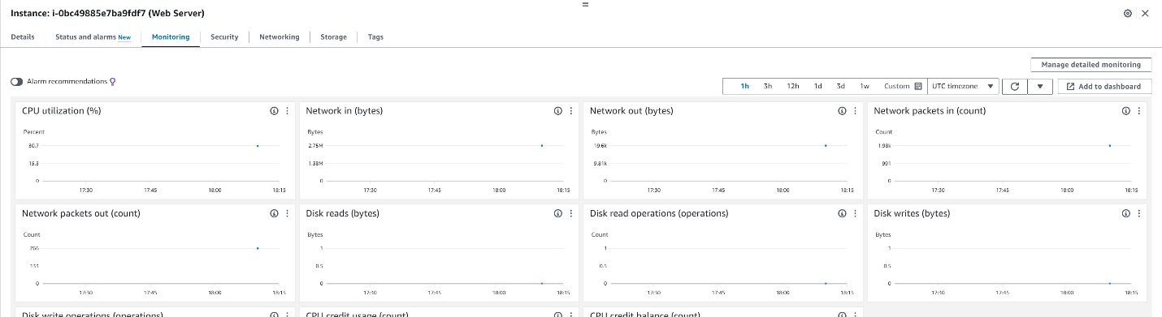

Step 15: Under the Actions menu at the top of the console, choose Monitor and troubleshoot and then Get system log (The system log shows the instance’s console output which is an important tool used for troubleshooting).

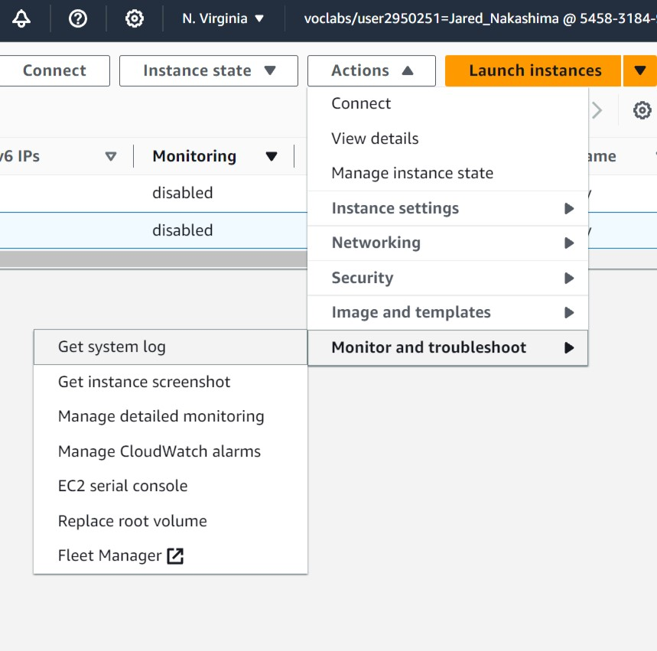

Step 16: Look through the instance’s output and note that the HTTP package has been installed from the user data that you added when creating the instance. Then select Cancel.

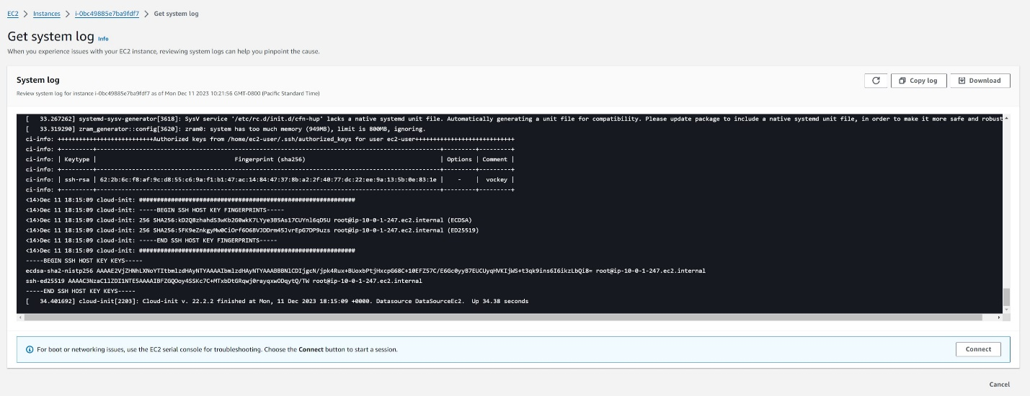

Step 17: Make sure Web Server is still selected. Then under the Actions menu, choose Monitor and troubleshoot and then Get instance screenshot (Displays how your Amazon EC2 instance console would appear if a screen were attached to it). Then select Cancel.

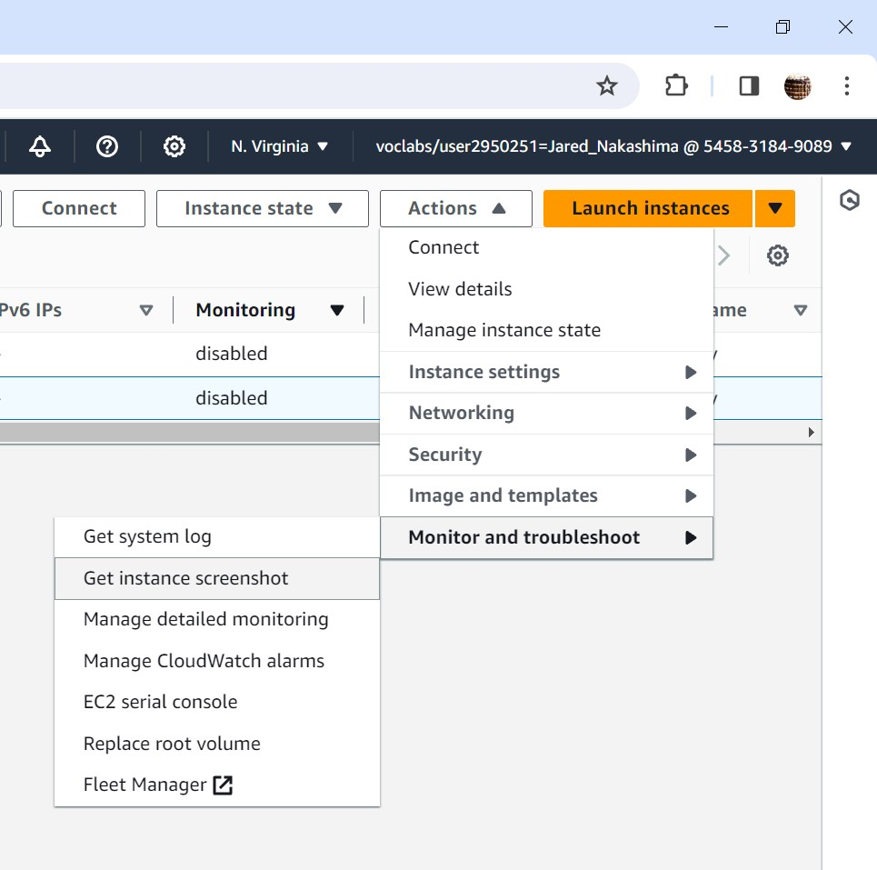

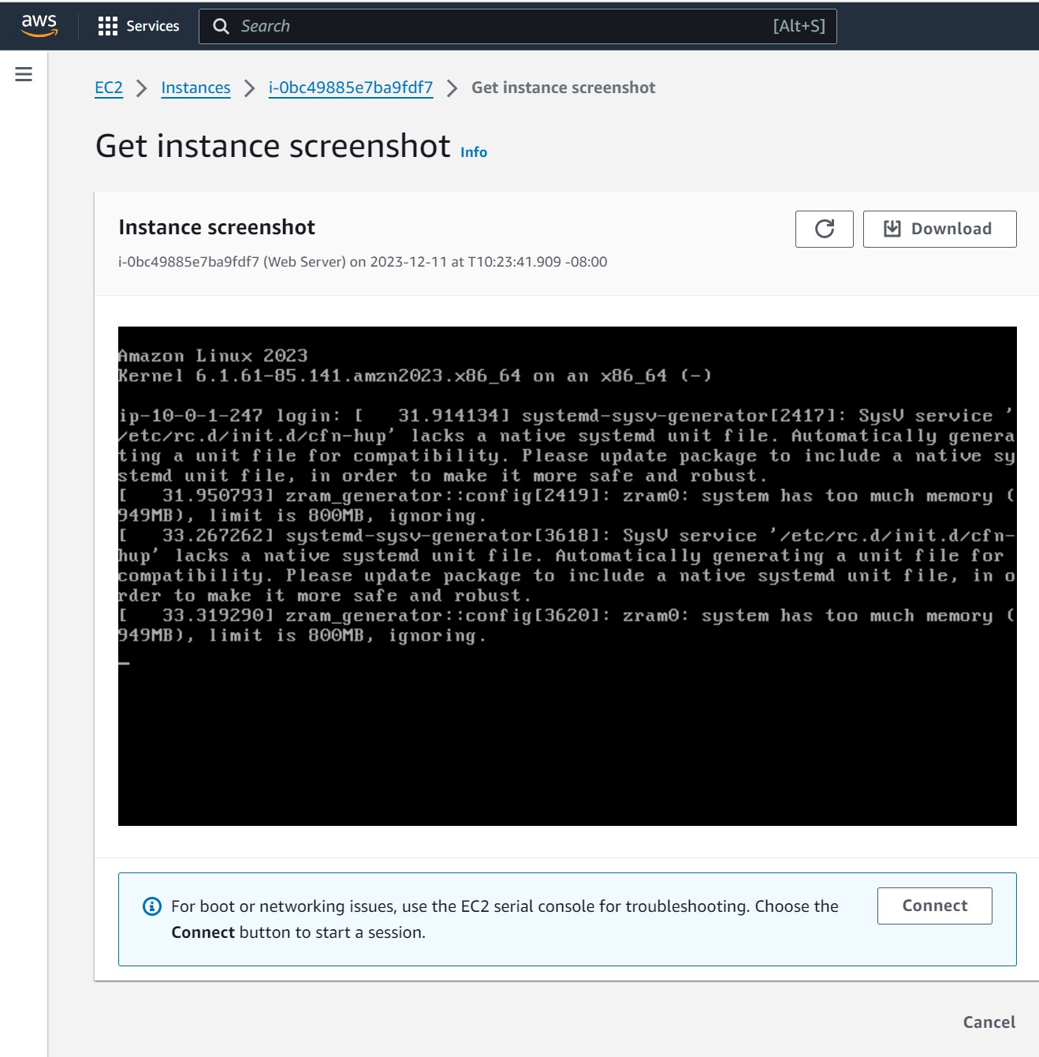

Step 18: Make sure Web Server is still selected. Click on the Details tab and copy your instance’s Public IPv4 address to your clipboard.

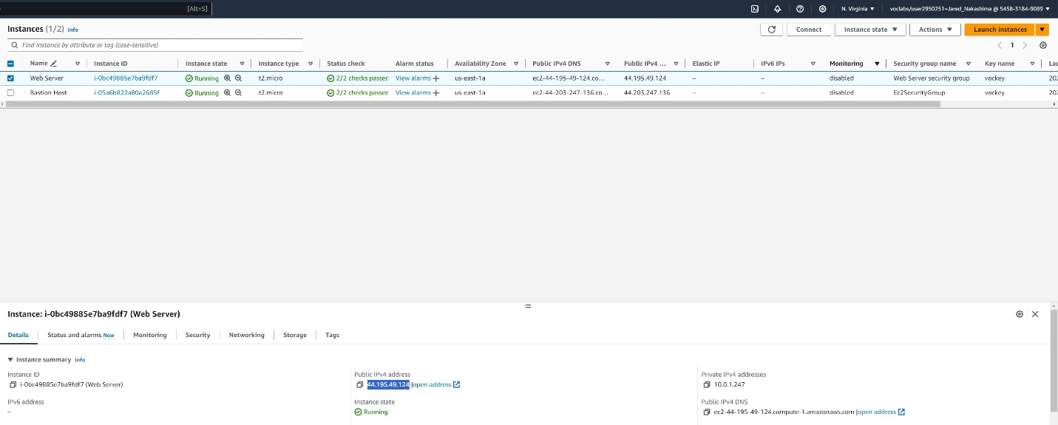

Step 19: Paste the Public IPv4 address into a new tab in your web browser and press Enter (You should currently not be able to access your web server because the security group does not permit inbound traffic on port 80, which is used for HTTP web requests).

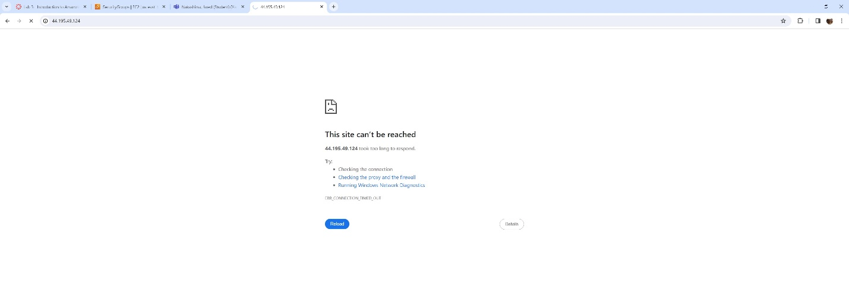

Step 20: Return to the EC2 Console, and in the left side bar, select Security Groups. Make sure Web Server security group has been selected and then click on the Inbound Rules tab and select Edit inbound rules.

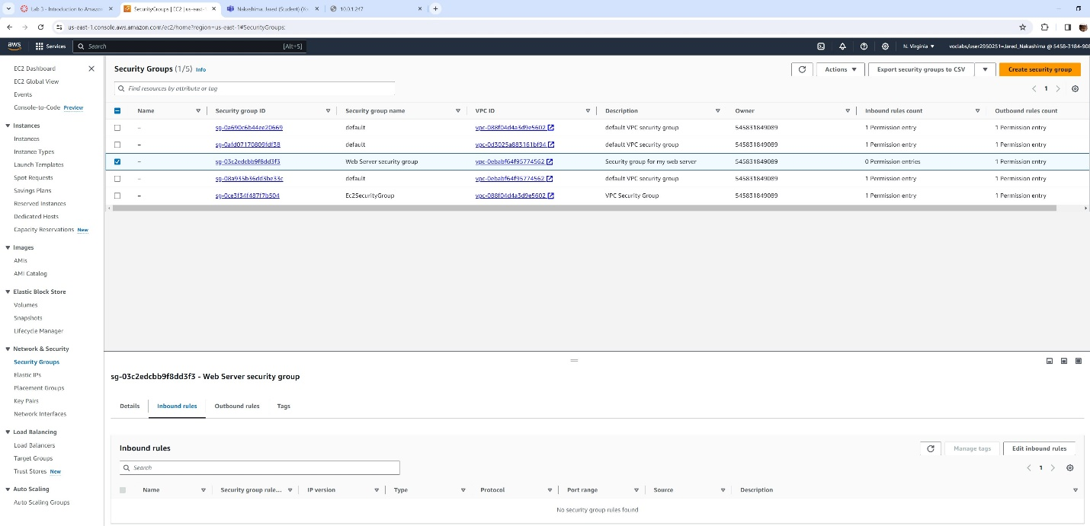

Step 21: After selecting Edit inbound rules, choose Add rule and then configure the rule as follows: Type: HTTP; Source: Anwhere-IPv4. Select Save rules.

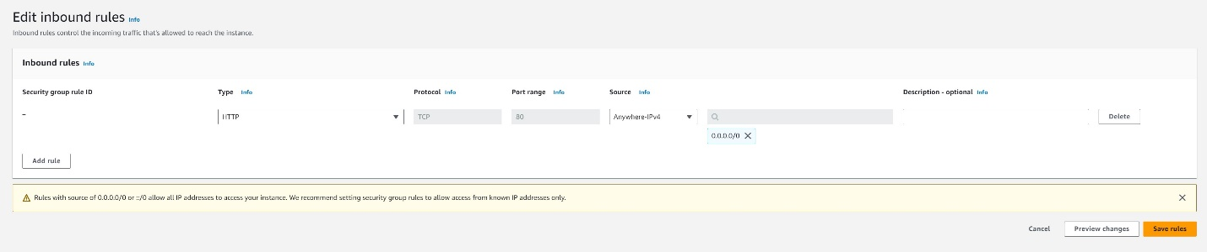

Step 22: Return to the web server tab and refresh the page. The message Hello From Your Web Server! should appear.

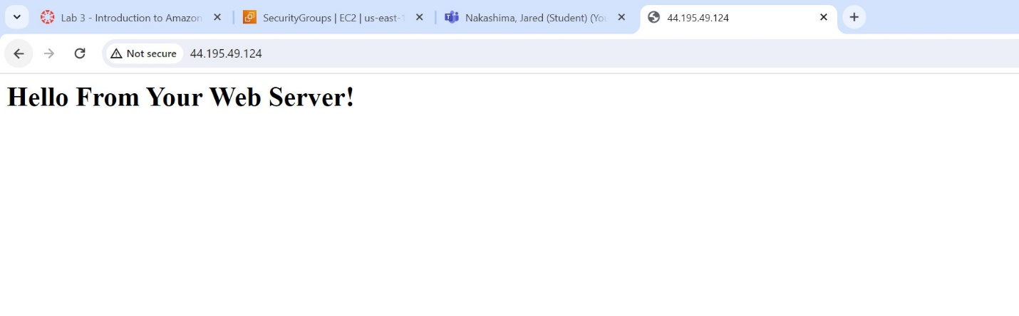

Step 23: Return to the EC2 Management Console and select Instances in the left sidebar. Web Server should still be selected. Under the Instance State menu, choose Stop Instance.

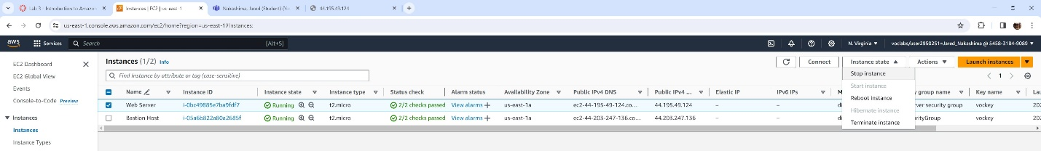

Step 28: Select Stop (Your instance will perform a routine shutdown and then stop running).

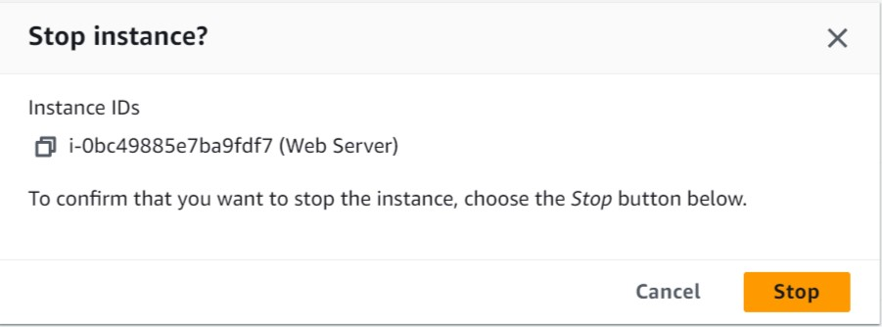

Step 24: Wait for the Instance state to show: Stopped.



Step 25: Under the Actions menu, choose Instance Settings, then Change Instance Type, and configure: Instance Type: t2.small and then select Apply.

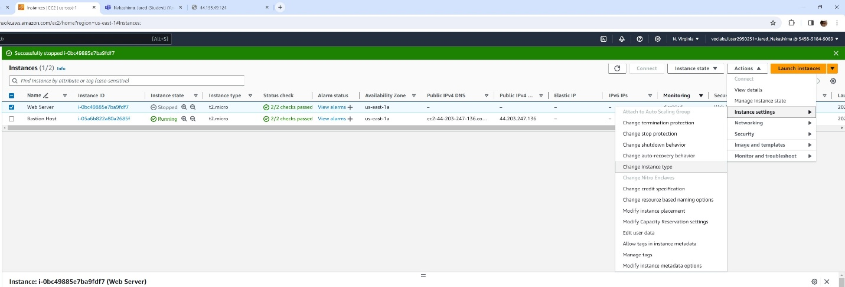

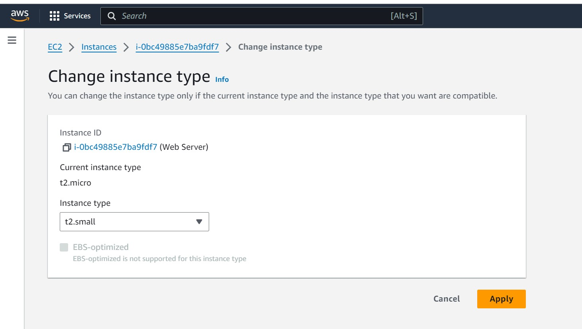

Step 26: Making sure the Web Server instance is selected, choose the Storage tab, select the name of the Volume ID, and then click the checkbox next to the volume displayed.

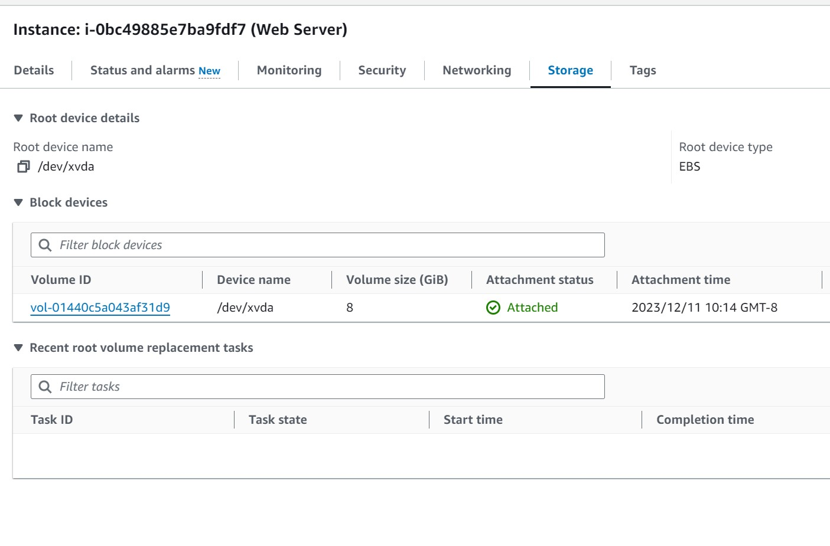

Step 27: Under the Actions menu, choose Modify Volume.

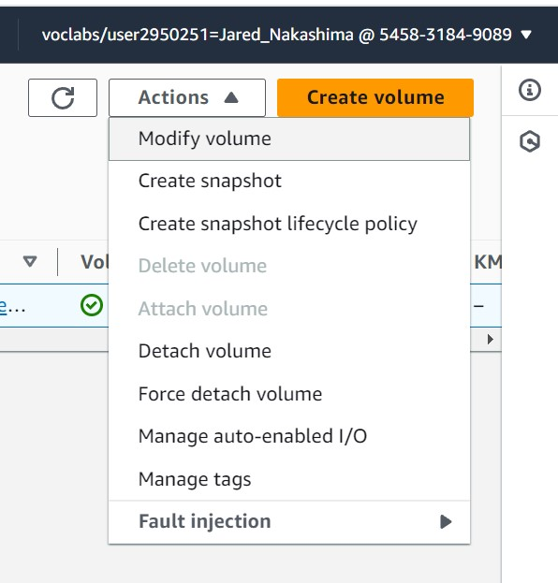

Step 28: Change the volume size to: 10. Select Modify. Then select Modify again to confirm the modification increasing the size of the volume.

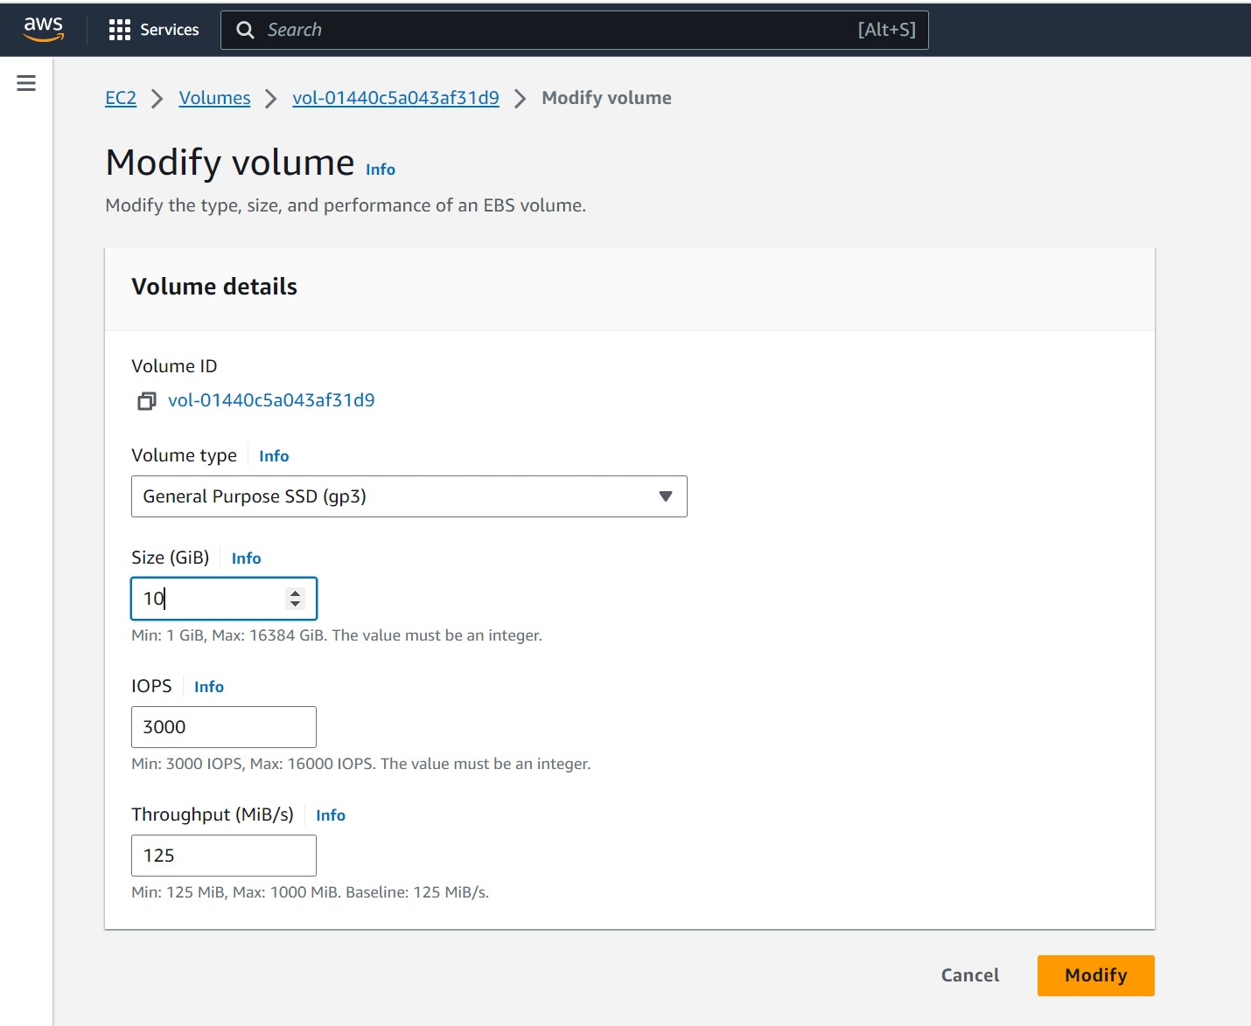

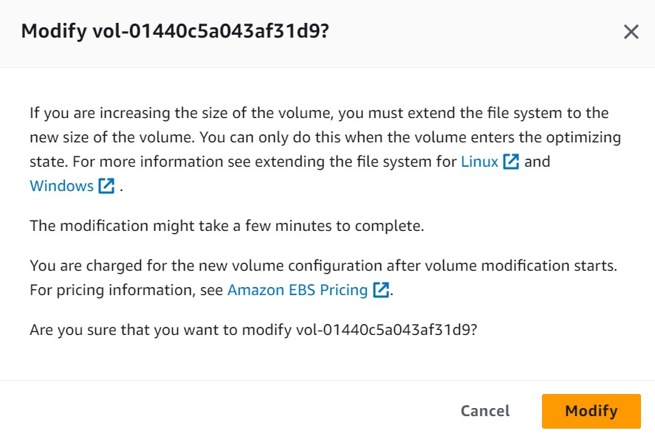

Step 29: In the left side bar, select Instances. Select the Web Server instance. Under the Instance State menu, choose Start Instance.

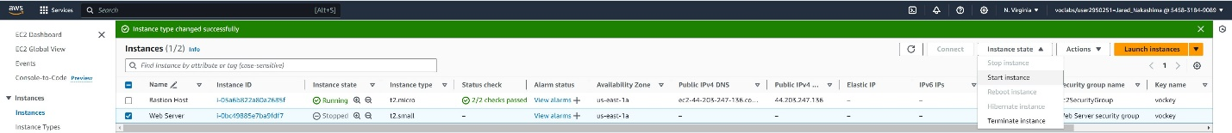

Step 30: In the AWS Management Console, in the search box next to Services, search for and select Service Quotas.

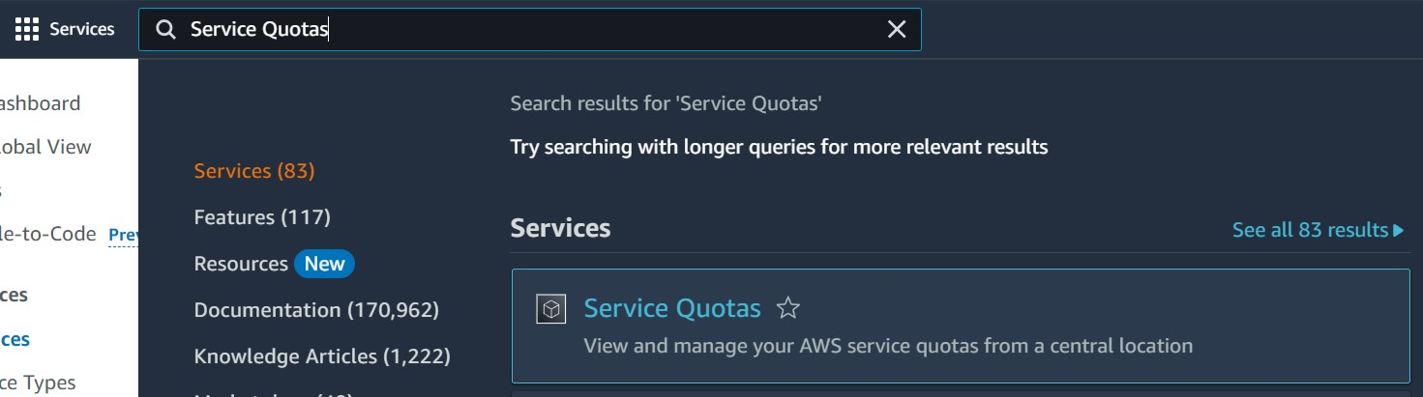

Step 31: Select AWS Services from the navigation menu and then in the AWS services Find Services search bar, search for ec2 and then select Amazon Elastic Compute Cloud (Amazon EC2).

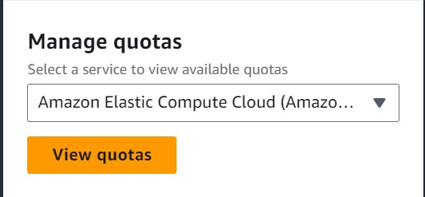

Step 32: In the Find quotas search bar, search for running on-demand, but do not select. Rather, observe the list of service quotas matching the criteria.

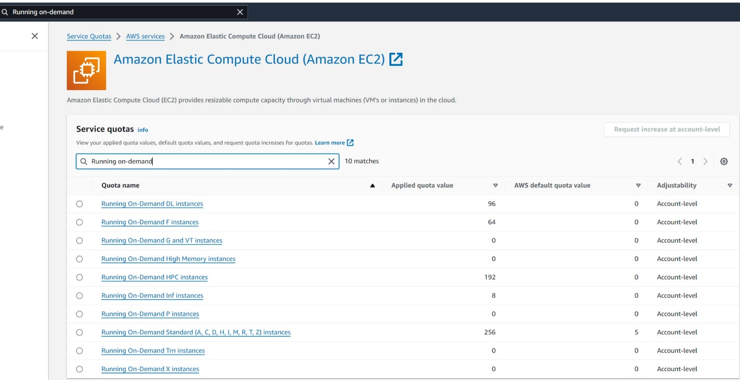

Step 33: In the AWS Management Console, in the search box next to Services, search for EC2 and go back to the EC2 console.

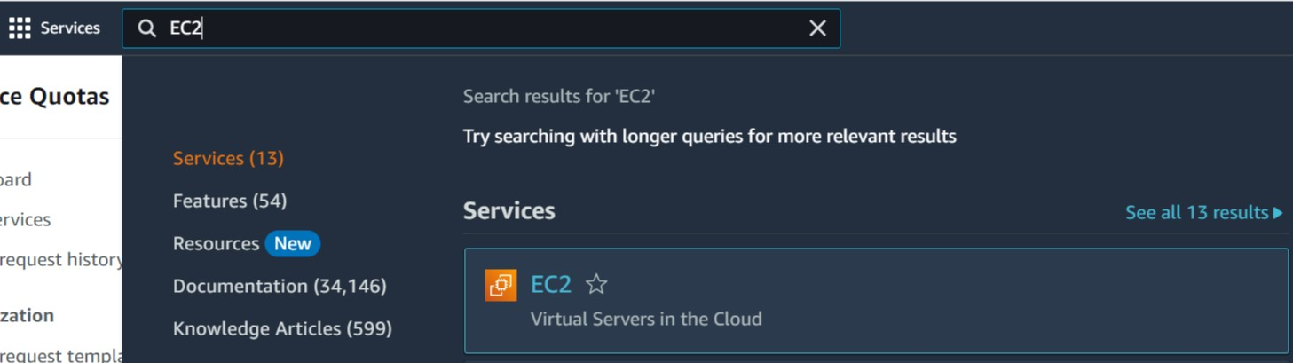

Step 34: In the left sidebar, select Instances. Make sure the Web Server instance is selected and under the Instance State menu, choose Terminate Instance.

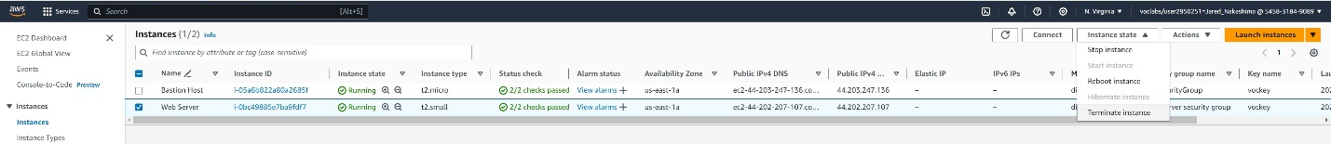

Step 35: Choose Terminate (A message will appear saying the instance failed to terminate, so first we must disable the termination protection).

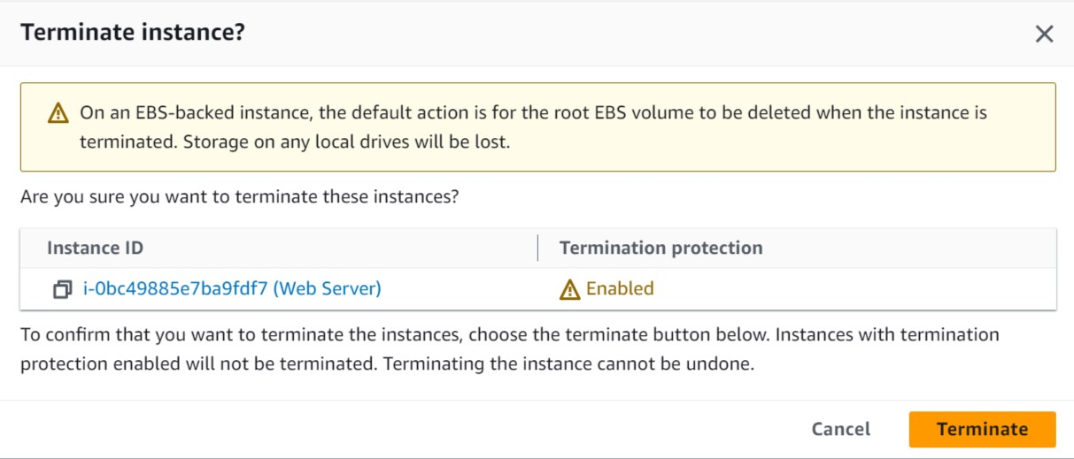

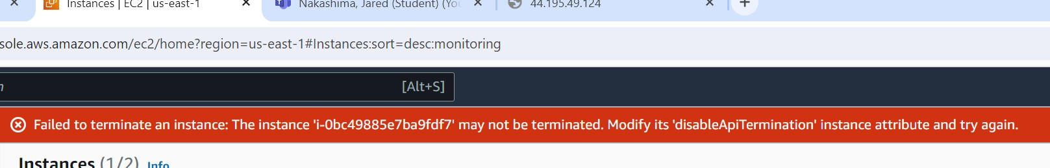

Step 36: Under the Actions menu, choose Instance Settings, and then Change Termination Protection.

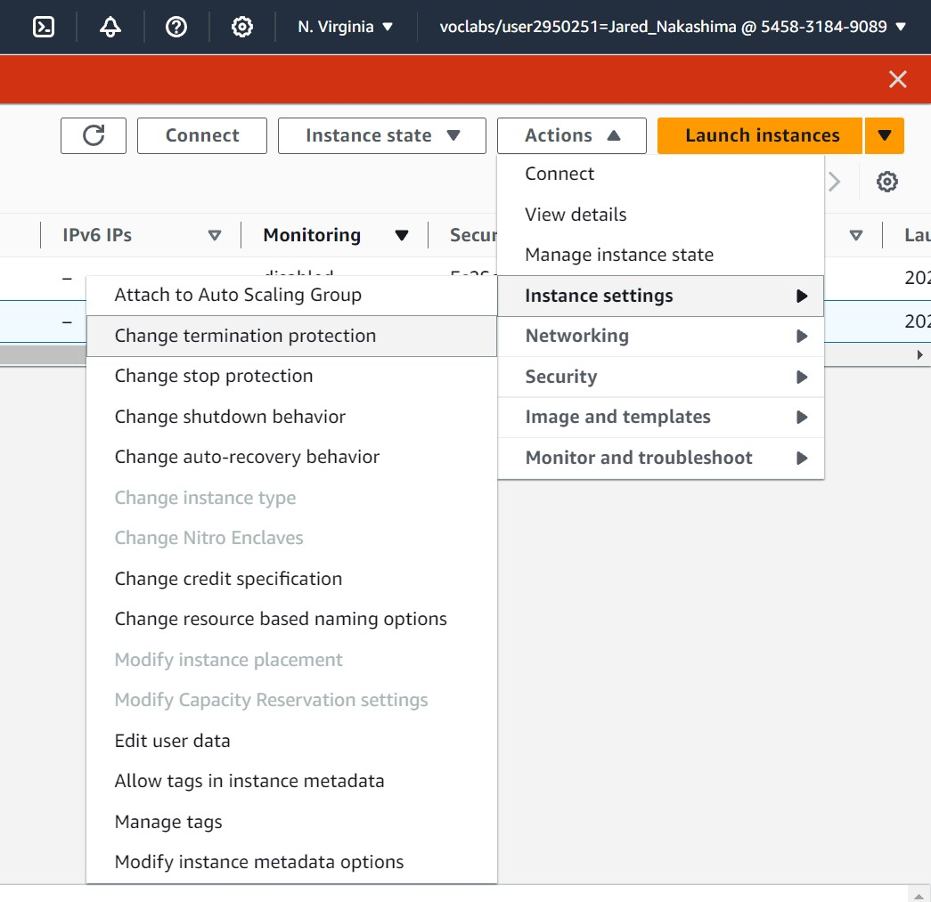

Step 37: Remove the checkmark next to Enable. Select Save. (You are now able terminate the instance).

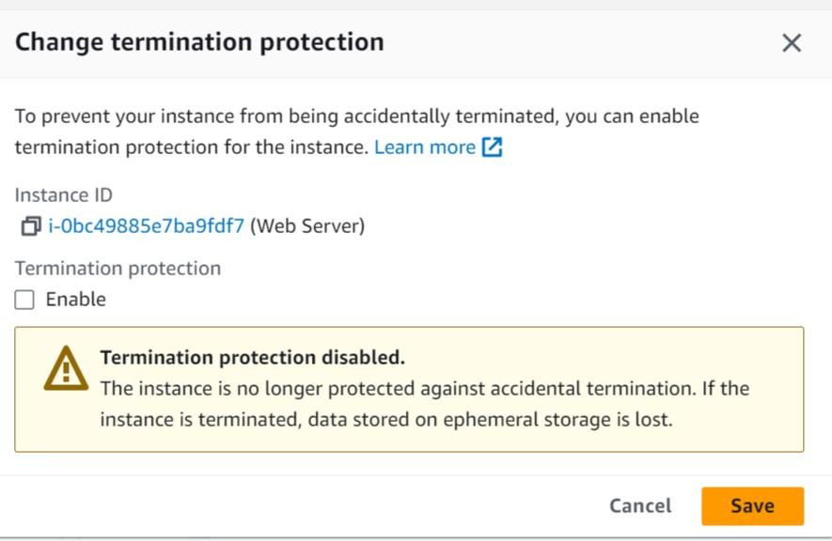

Step 38: Reselect the Web Server Instance and under the Instance State menu, choose Terminate Instance. Select Terminate.



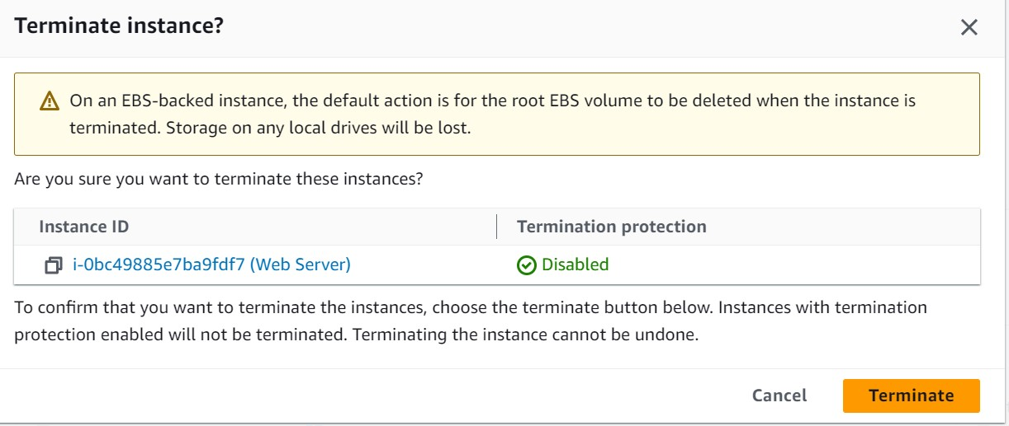

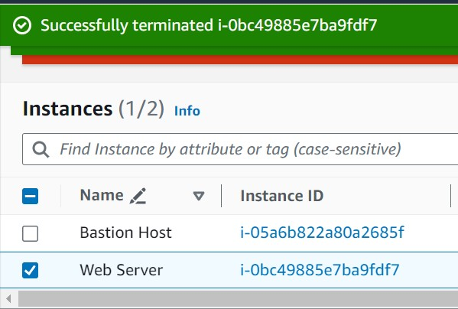

Problems:

Lab 1: IAM Experience - While working on the lab, I found that the changes I made to my created groups were unexpectedly disabled when I returned to the IAM console. To fix this, I carefully reviewed and compared each step of the lab to my existing console configuration.

Lab 2: VPC Setup and Web Server - In the lab, I misunderstood the term "lab" as "Tab" in the naming of my VPC's settings. Although this didn't cause significant errors, it might lead to confusion when reading through the steps of my lab writeup.

Lab 3: EC2 Incident - In one step, I mistakenly pasted the Private IPv4 address instead of the Public IPv4 address into a new browser tab, resulting in an error. After realizing the mistake, I had to backtrack, disable settings, and correctly copy and paste the Public IPv4 address. It was later identified that the initially copied address started with "10," indicating its membership in a private pool of IPs.

Conclusion:

These labs gave me a solid understanding of setting up essential aspects of AWS services. This knowledge is crucial for understanding why Amazon is a top choice for building secure network systems. AWS provides a range of services, and many companies are shifting to its virtual services due to features like pay-as-you-go pricing and easy accessibility.

These exercises help users see how configurations impact their virtual networks, eliminating the need for on-premises cloud networks that might compromise security. The key lesson is that configuring instances and subnets in the service's console involves multiple steps. However, this detailed process ensures AWS offers the most secure network, along with user-friendly management for organizations.

What I learned is that these intricate configurations aim to guarantee a secure network with AWS, making it an efficient solution for companies. AWS takes care of the operational aspects, providing a convenient and reliable way for organizations to manage their systems effectively, saving administrators and users from unnecessary burdens.